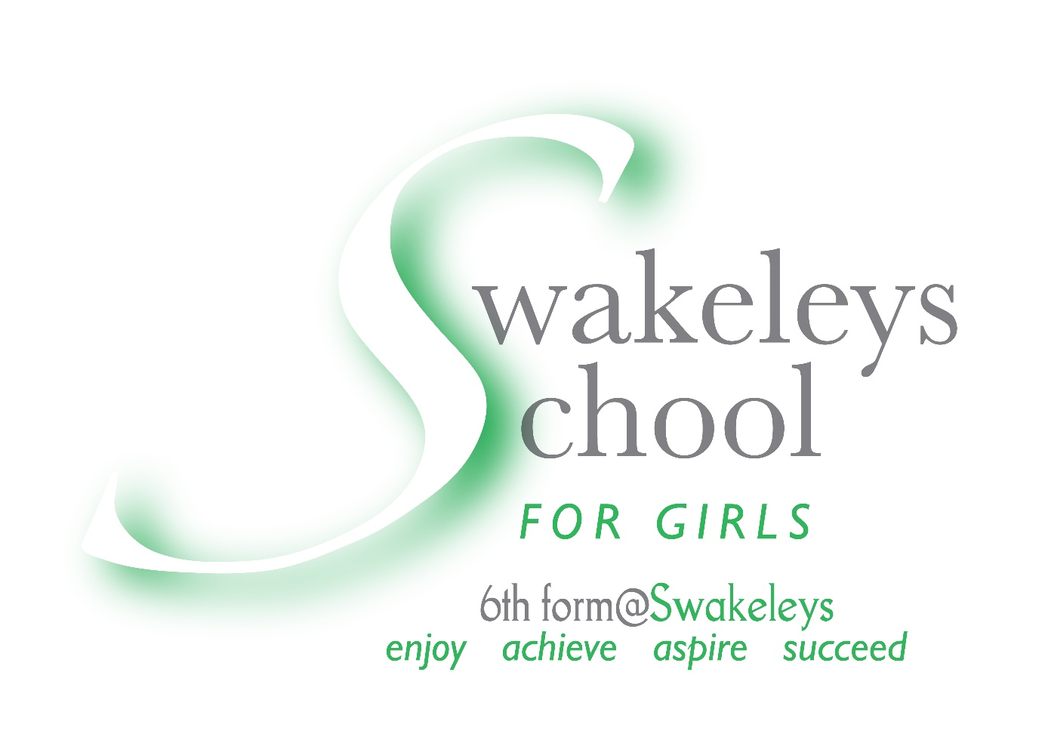
Swakeleys School for Girls

CEIAG
Strategic Action Plan

Careers Education Information Advice Guidance

CAREERS PROVISION AT SWAKELEYS SCHOOL FOR GIRLS AND SIXTH FORM
Careers Staff
- Mrs P Laguillo – Assistant Headteacher, School Careers Leader (KS3 / KS4)
- Mr A Bremner – Assistant Headteacher, School Careers Leader (KS5)
- Mr R Williams – Independent Careers Advisor
- Mrs K Doyle – Work experience administrative assistant
Vision
To provide ALL pupils with high quality careers guidance and an educational programme which will raise the aspirations and achievement of ALL our pupils.
Careers education at Swakeleys School for Girls is committed to helping our students develop the skills and knowledge to make successful careers choices, manage their transitions in learning and feel prepared and confident in the next phase of their life. Whether this be in further education, entering the world of work or training through apprenticeships.

Swakeleys School for Girls has a statutory duty to adhere to the careers strategy and the statutory guidance published in July 2021 and is committed to working towards achieving the eight Gatsby Benchmarks.

The 8 Gatsby Benchmarks are:

1-A stable careers programme
Every school and college should have an embedded programme of career education and guidance that is known and understood by pupils, parents, teachers, governors and employers.

2-Learning from career and labour market information
Every pupil, and their parents, should have access to good quality information about future study options and labour market opportunities. They will need the support of an informed adviser to make best use of available information.

3-Addressing the needs of each pupil
Pupils have different career guidance needs at different stages. Opportunities for advice and support need to be tailored to the needs of each pupil. A school’s careers programme should embed equality and diversity considerations throughout.

4-Linking curriculum learning to careers
All teachers should link curriculum learning with careers. STEM subject teachers should highlight the relevance of STEM subjects for a wide range of future career paths.

5-Encounters with employers and employees
Every pupil should have multiple opportunities to learn from employers about work, employment and the skills that are valued in the workplace. This can be through a range of enrichment activities including visiting speakers, mentoring and enterprise schemes.

6-Experiences of workplaces
Every pupil should have first-hand experiences of the workplace through work visits, work shadowing and/or work experience to help their exploration of career opportunities and expand their networks.

7-Encounters with further and higher education
All pupils should understand the full range of learning opportunities that are available to them. This includes both academic and vocational routes and learning in schools, colleges, universities and in the workplace.

8-Personal guidance
Every pupil should have opportunities for guidance interviews with a career adviser, who could be internal (a member of school staff) or external, provided they are trained to an appropriate level. These should be available whenever significant study or career choices are being made. They should be expected for all pupils but should be timed to meet their individual needs.

Strategic Objectives
Objective 1 – To improve the electronic tracking and recording of careers events and destination data through the use of Compass+ and Unifrog.
- Train all staff on how to use Unifrog to feel confident logging activities
- Encourage CL’s and departments to incorporate careers activities
- Central recording of destination information

Objective 2 – To promote careers education in the curriculum across all year groups.
- To support and encourage staff to lead CEIAG initiatives in their subject areas
- For all staff to incorporate careers in their teaching and lessons
Objective 2 – To continue developing a programme of encounters to meet the individual needs of all students by creating a network of employers / employees and educational providers to support learning.
- Continue to develop links with organisations and build on existing relationships
- Develop an Alumni support

The Careers team at Swakeleys School for Girls provides careers education information, advice and guidance (CEIAG) to students so they can develop the skills needed for a working life. This supports the more general careers education students receive in subject lessons, form group tutorials, assemblies and general careers events.
Careers guidance and education is delivered in all key stages as an integral part of the PSHCE programme. In sixth form, the careers guidance is expertly supported by external advisors who provide bespoke guidance on the UCAS process to students and parents.
From Year 8 onwards, pupils are given progressive support to inform option choices, to prepare for work experience, reflect on career choices and to research career opportunities. For our Year 11 students we provide particularly intensive support as they make important decisions about which Post-16 pathway to follow: academic A Levels; vocational BTECs; or workplace Apprenticeships.
Swakeleys School for Girls and Sixth Form works in partnership with Education Development Trust (EDT) to employ an independent careers advisor (Mr Richard Williams) who delivers impartial careers advice and guidance to learners and parents / carers of pupils in the school. Every student from Years 7 to 13 will have access to a careers interview which is individually tailored to their particular needs. Personalised action plans are developed with the student during the meeting and their execution is monitored by the student’s Form Tutor and via a follow up careers meeting should this be required.
A careers advisor is present at Year 11 Parents Evening and on GCSE / A-level Results Day to help and guide students in making informed choices about their future.
Swakeleys School for Girls and Sixth Form is keen to promote the STEM agenda and we are committed to promoting careers in science, technology, engineering and maths. Numerous events, integrated into the careers programme offers providers from different industries to share their knowledge and experience of their field of work.
Swakeleys School is committed to students experiencing the real world of work through a two–week work experience programme in Year 10. We work in partnership with an external agency to ensure that qualitative placements are sourced as part of this programme that will hopefully help to inform their future study pathway. Students often refer to the experience and skills they have developed through their work placements in future job application or in their UCAS personal statements. During the COVID pandemic, unfortunately face to face work experience has not been possible and instead we have worked hard to engage pupils with the many virtual opportunities on offer.
Throughout the year, we engage in events offered by companies and external agencies to maximise our students exposure to the world of work.

Careers Programme
Year group | Content  Term 1 | Term 2 | Term 3
7
8
9
10
11
12
13

