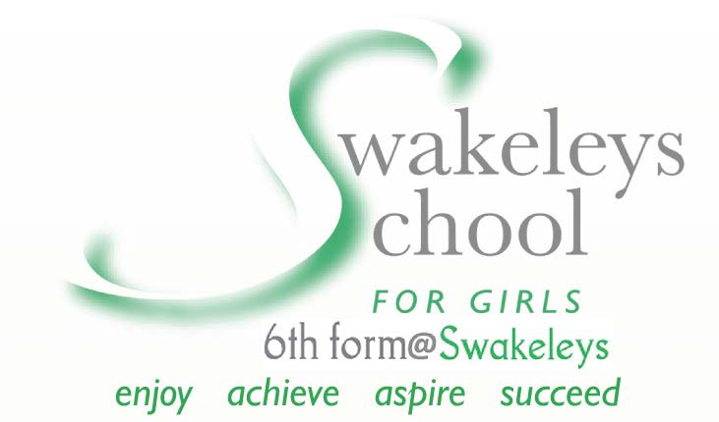
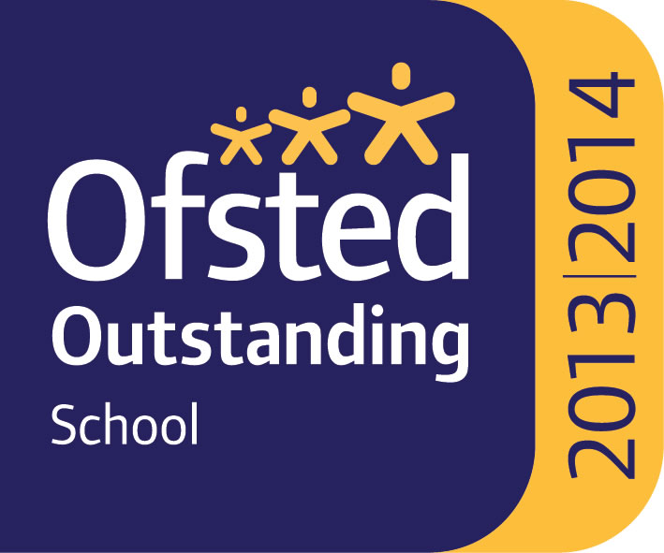

Media & Film Studies

The Media Studies Department has one specialist teacher who also the Curriculum Leader for the subject. The media department also has a second subject teacher within the department.

The department is based in the hub of a brand new school building with fantastic facilities for the subject area. This includes two brand new mac suits with industry standard software including Final Cut Pro X, and Adobe suit including Photoshop. The macs run a dual log on with both windows and Apple operating systems. The department is also well resourced in terms of cameras and equipment, with access to DLSRs tripods and sound recording equipment bookable via staff. Both media rooms are well resourced with text books and teaching materials.

Departmental Aims
Media studies is an analytical and critical subject. It offers learners the opportunity to develop a thorough and in depth understanding of media using a comprehensive theoretical framework and a variety of advanced theoretical approaches and theories to support critical exploration and reflection, analysis and debate. The study of a wide range of rich and stimulating media products is central to the specification, offering opportunities for detailed analysis of how the media communicate meanings in a variety of forms. The department aims to equip students with the ability to think critically and analyse media products using theoretical perspectives. The media studies department aims to achieve the following:
- A safe, rewarding and stimulating learning experience for students
- Develop a critical, analytical approach to media issues confidently in order to participate successfully in an increasingly technological world
- Develop appreciation and critical understanding of the media and their role both historically and currently in society, culture, politics and the economy
- Apply theoretical knowledge and specialist subject specific terminology to make informed arguments, reach substantiated judgements and draw conclusions about media issues
- Encourage students to engage in critical debate about academic theories used in media studies
- Develop sophisticated practical skills by providing opportunities for creative media production. Critique, evaluate and test their ideas and products and the work of others

Current courses on offer:

Media Studies is an option subject. Students start studying their option subjects from year 9. Pupils who have chosen to study media studies will begin a full GCSE three year course. Our examination results are consistently excellent and the pupils are well motivated to work to high standards. We follow the Eduqas exam board for GCSE and A Level.

In Year 12 students follow the Eduqas linear specification in our mixed 6th Form Centre. In year one students complete the AS qualification including two exams (70%) and one piece of individual non-examined assessment (30%). In Year two students complete the second year of the qualification including two exams (70%) and one piece of individual non-examined assessment (30%), additional theorists and new set texts.

2019 Results:
GCSE Media Studies
9-7: 42%
9-5: 92%

AS Media Studies
A*-A: 19%
A*- C: 88%
A2 Media Studies
A*-B: 78%
A*- C: 100%

A2 Film Studies (2016)
A*-A: 17%
A*- C: 100%

