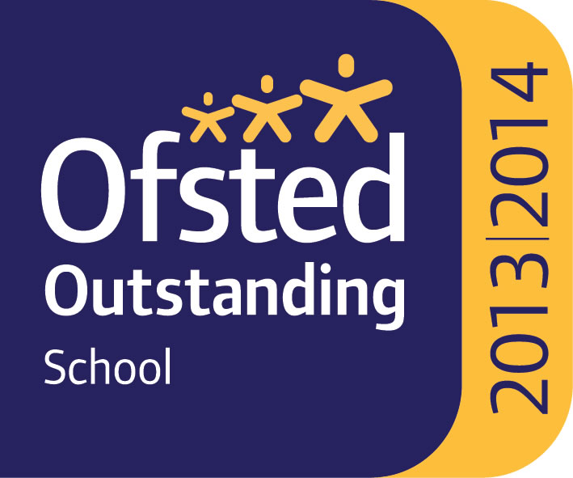

Mathematics

The Maths Department is a strong and supportive team of eleven teaching staff. The team includes teachers in the early stages of their teaching careers and many highly experienced staff. The team includes a Curriculum Leader, 2nd in Dept (in charge of KS4), a 3rd in Dept (in charge of KS3), a teacher in charge of KS5 and a numeracy Co-ordinator.

The Maths Department has its own suite of nine rooms on the top floor of a new modern school building. In addition, there is a dedicated work space where the maths teachers meet to share ideas. All Maths rooms are well resourced with text books and teaching materials and have interactive whiteboards.

All year groups are set by ability, in two half year bands. Teachers use a variety of teaching methods and materials to ensure that pupils are engaged, motivated to succeed and enjoy maths. There are a variety of extra-curricular activities to promote the subject further, eg Maths Challenge and Maths Masterclasses. Take up of maths at A Level is good and additionally Further Maths is offered.
Whole school numeracy is developing well with a programme of activities in Form Time, Numeracy Word of the Week and a House staff and student Numeracy Challenge.

We are a strong and committed department with the desire to help our students develop their problem solving and mathematical knowledge and skills to become confident young learners who enjoy maths.

Departmental Aims

The maths department aims to achieve the following:
- A rewarding and stimulating learning experience for students
- The learning and application of maths to the world of today
- Specific and measurable learning outcomes in preparation for examinations
- A broad range of transferable skills and useful knowledge in preparation for further study
and/or working life

Current courses on offer:

- KS4: (studied over 3 years starting in year 9)
  - GCSE Mathematics (AQA)
- KS5:
  - A Level Mathematics (Edexcel)
  - A Level Further Mathematics (Edexcel)

2019 Results:

GCSE 67% 9-5
A Level A*-B 59% (with 82% A*-C)

February 2022

