July 2021 Swakeleys Careers News
This page is to provide students and parents with the most up to date information relating to a variety of CAREER NEWS including; work experience, internships, apprenticeships, volunteering, summer schools, STEM opportunities and master classes.
Whilst we are encouraging our students to apply for external courses please note that the organisations offering these activities are entirely separate to the school. Swakeleys School for Girls has not carried out any risk assessments in relation to these activities. For this reason, Swakeleys School for Girls informs you of, but does not endorse, external provider opportunities and will not accept any liability arising from student participation in these activities.

Since the last newsletter many more pupils have participated in in virtual work experience opportunities via Springpod or Speakers for School:

Naina Ansel – Allied Health Professions NHS
Khushi ASIM – Engineering work experience Springpod
Amrit Bharat – Finance Virtual WEX
Navjot Brar – Law Virtual WEX
Ahlan Galambi – Hospitality WEX Springpod
Kiran Haq – Law & NHS Virtual WEX Springpod
Amna Hasme – Hospitality WEX Springpod
Soha Jamal – Allied Health Professions NHS
Jekasini Jayaharan – Finance & Business management Springpod
KAPOOR Rhythm – Nursing and midwifery virtual WEX
KHALID Laiba – Teaching virtual WEX
KUGATHAS Aranja – Next GEN nursing, meet the people behind the mask
Amira Mohamed – Teaching virtual WEX
Shivani Patel – Marketing virtual WEX
Eena Rizwan - Finance WEX Springpod
YUSUF Anisah – Dentistry Virtual WEX

Congratulations to all of the above pupils and well done for being pro-active in seeking out these opportunities. The feedback that we are getting from pupils who participate in these events is really positive.

Careers News / Opportunities
There are lots of opportunities being offered, so please do read the information below carefully.
  - Careers Appointments with our independent careers advisor – Richard Williams have continued all through lockdown. We are now making careers appointments for pupils in all year groups.
Please use the Google docs form to sign up for a careers appointment. https://forms.gle/iLwnstaC4d5fhg9C7
All students who apply for Virtual WEX opportunities must complete the following form giving parental / carer consent.
https://docs.google.com/document/d/18KIgfU6gXIRbjYY29pf9qOhFeA05Kq44qyx-wxH-pvM/edit?usp=sharing
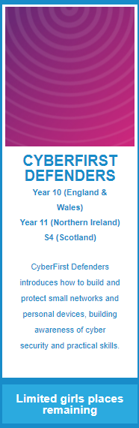

Do you have an interest and aptitude for computers?
Cyber first courses use hackathons, team tasks and hands-on challenges to teach the problem-solving skills our digital society is looking for.
Inspired and led by the National Cyber Security Centre (NCSC), a part of GCHQ, CyberFirst introduces young people with a passion for computing and our digital world to the intricacies and opportunities of cyber security.

Please Click on each of the links above to apply

We wanted to tell you about TWO really cool challenges that help you see if Business or Law is for you through these brilliant immersive and interactive tools.
The Business Challenge looks at business, advertising, marketing, finance and entrepreneurship whilst the Law Challenge focuses on Policing, Criminology and Law (think becoming a lawyer).
They are both free to use and both offer top prizes. Try them today.
Law Challenge
Business Challenge

Speakers4School (suitable for Yr 7-13)
A Virtual Talks Programme. They have been offering free live streamed talks from some of the UK’s top leading figures. Students will be able to hear masterclasses and interviews from speakers from across: business, arts, academia, media and more. Speakers will be sharing their own stories and expertise on a variety of subjects.

You can see the schedule of talks here! Please distribute this link to your daughter.

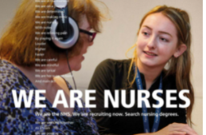
Interested in a rewarding career in nursing?
Below is a link which you can sign up to in order
to receive updates directly from the NHS about
nursing careers. It is FREE and will have all the most up to date information on how to become a nurse. https://bit.ly/3yar8lk

Next week we are very excited to be taking part in the London Careers Festival.

Virtual Career Chats on Tuesday 29th June at 9.30 to 10.30 am
Workshop title: KS3 workshop: 'Tech jobs of the future'
Description: A variety of digital and tech sector volunteers from familiar brands and tech giants to robotics to those working in digital aspects of other sectors such as arts or health can talk to students. This session will focus on future-focused jobs and provide students with LMI quiz about employment opportunities in digital and tech. Year 7-9

Virtual Career Chats on Wednesday 30th June at 11.30 to 12.30 pm
Workshop title: Secondary KS4 workshop: 'Pathways into Law'
Description: In this session, we will aim to showcase how legal jobs exist in most sectors including education, health, transport and arts and that there is a legal element to most organisations. We will also aim to showcase how law firms have a range of jobs that don’t require a legal qualification. Volunteers can discuss pathways into law and the range of qualifications available in the profession. Year 10

Virtual Career Chats on Wednesday 30th June at 2.00 to 3.00 pm
Workshop title: Secondary workshop: 'Becoming an Influencer (Marketing & Social Media)'
Description: Students can hear about the essential skills that go into effective marketing from a range of volunteers from huge companies such as, ITV and Google to smaller businesses. Students can be tasked with a short enterprise activity to design their own social media post or slogan within the space of the session to contribute via the chat function. Year 9 & 10

Places per workshop are strictly limited to 20. Please sign up on the Google form link to sign up. Deadline: Monday 28th June - 10am

https://forms.gle/vdMB3Pc2f5wRJFg77

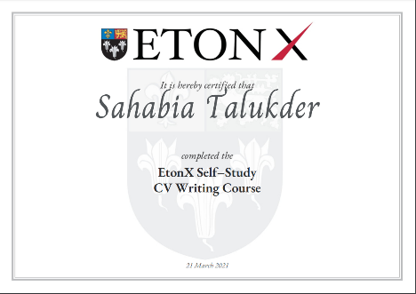
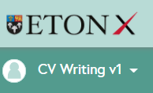

EtonX – Online CV Writing Course
We now have 19 pupils in total who have completed and received their certificates for completing the EtonX online course.
- Abbigale Gladney
- Navjot Brar
- Jekasini Jayaharan
- Amira Mohamed
- Bari Khan
- Kiran Haq
- Chardonnay Marchant
- Laiba Khalid
- Amna Hasme

Congratulations to the above students for completing the course since the last newsletter! We have allocated some time during Sports Day for those of you signed up to the course to try and complete it.

Please don’t forget that the deadline by when to complete the course is
31st July 2021.

We now have 60 pupils who have signed up to this excellent website and I am delighted to report that 3 of our pupils have been selected and recognised for their achievements.

UpskillMe allows students from years 7-13 to build a digital record of achievement and showcase their full range of talents, skills and activities. They can record any awards they’ve won, youth programmes they are on, or projects they’re proud of - both in and out of school. That way, when they’re applying for jobs and further education, they’ve got everything they need - it’s all in one place. Each students’ portfolio can be downloaded or shared into a job or UCAS application via a sharable link.

Students can also access their opportunity portal which lists hundreds of work experience placements, careers advice and virtual events in law, medicine, finance and technology amongst many others. Your students will earn points, badges and prizes including Amazon and Nando's vouchers for improving their employability.

To find out more about how to sign up, please listen to the short presentation on https://vimeo.com/455218384/7760338b15

Sign yourself up and start your digital careers record today that will help keep a record of all your key employability skills. Get ahead!

Useful websites for parents

- The single, most reliable and up to date careers website for all young people (11-19) on careers is https://careerpilot.org.uk/
- A government funded website is the National Careers Service. Its Job Profiles section contains descriptions of over 8oo jobs, with links to more specialist sources of information and guidance.
https://nationalcareersservice.direct.gov.uk/job-profiles/home
- Top website for parents, outlining options and offering sensible careers advice. http://www.parentadviser.co.uk/
- An excellent website with lots of updated information on Apprenticeships http://www.allaboutschoolleavers.co.uk/pare.
- There is also the main Apprenticeship website, government funded, which contains the vast majority of vacancies: Get In Go Far
https://www.getingofar.gov.uk/
https://amazingapprenticeships.com/
https://www.gov.uk/apply-apprenticeship

- Reliable and informative guide to selecting A Level subjects or BTECs, Informed Choices is written by the Admissions departments of all the Russell Group universities
https://www.russellgroup.ac.uk/media/5272/informedchoices-print.pdf
- Reliable information and support for parents with their child’s university applications and the UCAS process generally.
www.ucas.com/ucas/16-18-choices/help-and-support/ucas-progress-parents-andcarers
Useful websites for students
- The single, most reliable and up to date careers website for all young people (11-19) on careers is https://careerpilot.org.uk/
- Not sure what career you want to do? Explore the Job Profiles section of the Careers Service website for accurate information on hundreds of different jobs and Careers TV for video clips.
https://nationalcareersservice.direct.gov.uk/job-profiles/home
http://www.careers4u.tv/explore/
https://icould.com/
- Sign up to this website to explore careers, get the lowdown on top employers, and search for the latest jobs, courses and advice.
https://successatschool.org/
- A dynamic portal of 1000+ open days, tasters, study days and skills events. No registration, no fuss just a brilliantly fast site connecting you to events in seconds www.mystudentevents.com
- A great website offering useful links to information about jobs, qualifications, salaries and advice about CV writing etc.
http://schoolleavers.milkround.com
Research suggests that the majority of careers advice sought by young people is done using the internet rather than speaking with a careers adviser, professional or family member. It is vital that the right information is found.

