April 2021 Swakeleys Careers News
This page is to provide students and parents with the most up to date information relating to a variety of CAREER NEWS including; work experience, internships, apprenticeships, volunteering, summer schools, STEM opportunities and master classes.
Whilst we are encouraging our students to apply for external courses please note that the organisations offering these activities are entirely separate to the school. Swakeleys School for Girls has not carried out any risk assessments in relation to these activities. For this reason, Swakeleys School for Girls informs you of, but does not endorse, external provider opportunities and will not accept any liability arising from student participation in these activities.

This month we have once again had numerous pupils successfully apply to various work experience opportunities:

Megan Kaur – Vodafone work experience on Coding
Bari Khan - Teaching virtual work experience programme
Matten Khan – Law virtual work experience Springpod
Sabooh Khan – Nursing virtual work experience North West London
Amira Mohamed - Teaching virtual work experience programme
Jenanikca Pakeerathan

Congratulations to all of the above pupils and well done for being pro-active in seeking out these opportunities. The feedback that we are getting from pupils who participate in these events is really positive.

Careers News / Opportunities
There are lots of opportunities being offered, so please do read the information below carefully.
  - Careers Appointments with our independent careers advisor – Richard Williams have continued all through lockdown. We are now making careers appointments for pupils in all year groups.
Please use the Google docs form to sign up for a careers appointment. https://forms.gle/iLwnstaC4d5fhg9C7

All students who apply for Virtual WEX opportunities must complete the following form giving parental / carer consent.
https://docs.google.com/document/d/18KIgfU6gXIRbjYY29pf9qOhFeA05Kq44qyx-wxH-pvM/edit?usp=sharing

We now have 48 pupils who have signed up to this excellent website and I am delighted to report that 3 of our pupils have been selected and recognised for their achievements.

Sebha Basra (Yr 11) – Won a £50 Amazon voucher for entering and winning a category the Showcase Your Skills competition
Brooke Montgomery (Yr 11) - Certificate of recognition for being in the top 10 students for logging activities
Rana Al Zaeim (Yr 11) – Awarded a high achiever certificate

UpskillMe allows students from years 7-13 to build a digital record of achievement and showcase their full range of talents, skills and activities. They can record any awards they’ve won, youth programmes they are on, or projects they’re proud of - both in and out of school. That way, when they’re applying for jobs and further education, they’ve got everything they need - it’s all in one place. Each students’ portfolio can be downloaded or shared into a job or UCAS application via a sharable link.

Students can also access their opportunity portal which lists hundreds of work experience placements, careers advice and virtual events in law, medicine, finance and technology amongst many others. Your students will earn points, badges and prizes including Amazon and Nando's vouchers for improving their employability.

To find out more about how to sign up, please listen to the short presentation on https://vimeo.com/455218384/7760338b15

Sign yourself up and start your digital careers record today that will help keep a record of all your key employability skills. Get ahead!

Speakers4School (suitable for Yr 7-13)
A Virtual Talks Programme. They have been offering free live streamed talks from some of the UK’s top leading figures. Students will be able to hear masterclasses and interviews from speakers from across: business, arts, academia, media and more. Speakers will be sharing their own stories and expertise on a variety of subjects.

You can see the schedule of talks here! Please distribute this link to your daughter.

Biggest Entertainment Brand!
To celebrate our brand new partnership with Sky we will be putting on an Insight to Sky evening event taking place on Thursday 22nd April, 5pm - 6pm. We’ll be covering a variety of opportunities such as: business, tech, digital marketing, TV production, creative media, technical engineering and customer services. As well as this Sky will also be announcing some of their summer work experience / insight day opportunities that you can be part of! This event is open to all Y11 -Y13.
Top quality shows. Innovative tech. Must-have packages. With 24 million customers across six countries, it's no surprise that Sky is Europe's biggest entertainment brand. That's why they need the next generation of problem solvers, challengers and shakers to lead them into the future.
As well as discussing all their different opportunities they will also give you an overview on the business as a whole showing a clear picture on what life is working for one of the world’s leading entertainment businesses across all of their different departments.
If you’d like to apply to this event to find out more, please click on the application link below.
Application Link:
https://www.research.net/r/Insight-Sky

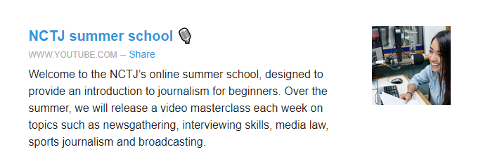

Click here to explore.

Global Academy have launched an excellent brand new Careers hub webpage as part of their own careers week. It’s a place to expose the exciting and different opportunities for students who have an interest in building a career in the creative sector. With over 70 organisations represented, it really is a great resource to explore and find out more about potential creative careers in many different industries.

It is all housed on the following link 👉 https://globalacademy.com/national-careers-week/ 👈

Explore their virtual careers fair!

Designed for 16-17-year-olds, NCS is an inclusive summer programme that helps teens get the skills, experience and self-belief they need to achieve their potential - and smash their future goals. Founded on the principles of social cohesion, social engagement and social mobility, NCS aims to make a life-changing difference to young people and how they approach life after school (something that can be daunting for even the most confident teens).
The programmes take place during various dates in the Summer and have been adapted to ensure that the programmes are COVID safe. There is an 3 week programme including (1 week residential+ 2 week non-residential) or a 2 week programme (non- residential).
The cost for the full programme is £50 with £10 bursaries available.
To find out more and register for this heavily subsidised opportunity click here.

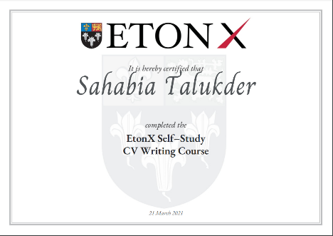
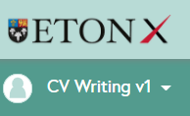

EtonX – Online CV Writing Course
The following girls have made great use of their lockdown time and have successfully completed the online course.
- Sahabia Talukder
- Jenanikca Pakeerathan
- Chevonnjeet Dhillon
- Laiba Saeed
- Anisah Yusuf
- Anushka Singh
- Khushi Singh

Congratulations for demonstrating excellent skills in perseverance and self – motivation. I hope that you enjoyed completing the course.

We have over 80 Year 10 students who have signed up to this course. Please don’t forget that the deadline by when to complete the course is
31st July 2021.

Mrs Laguillo

Useful websites for parents
- The single, most reliable and up to date careers website for all young people (11-19) on careers is https://careerpilot.org.uk/
- A government funded website is the National Careers Service. Its Job Profiles section contains descriptions of over 8oo jobs, with links to more specialist sources of information and guidance.
https://nationalcareersservice.direct.gov.uk/job-profiles/home
- Top website for parents, outlining options and offering sensible careers advice. http://www.parentadviser.co.uk/
- An excellent website with lots of updated information on Apprenticeships http://www.allaboutschoolleavers.co.uk/pare.
- There is also the main Apprenticeship website, government funded, which contains the vast majority of vacancies: Get In Go Far
https://www.getingofar.gov.uk/
https://amazingapprenticeships.com/
https://www.gov.uk/apply-apprenticeship

- Reliable and informative guide to selecting A Level subjects or BTECs, Informed Choices is written by the Admissions departments of all the Russell Group universities
https://www.russellgroup.ac.uk/media/5272/informedchoices-print.pdf
- Reliable information and support for parents with their child’s university applications and the UCAS process generally.
www.ucas.com/ucas/16-18-choices/help-and-support/ucas-progress-parents-andcarers
Useful websites for students
- The single, most reliable and up to date careers website for all young people (11-19) on careers is https://careerpilot.org.uk/
- Not sure what career you want to do? Explore the Job Profiles section of the Careers Service website for accurate information on hundreds of different jobs and Careers TV for video clips.
https://nationalcareersservice.direct.gov.uk/job-profiles/home
http://www.careers4u.tv/explore/
https://icould.com/
- Sign up to this website to explore careers, get the lowdown on top employers, and search for the latest jobs, courses and advice.
https://successatschool.org/
- A dynamic portal of 1000+ open days, tasters, study days and skills events. No registration, no fuss just a brilliantly fast site connecting you to events in seconds www.mystudentevents.com
- A great website offering useful links to information about jobs, qualifications, salaries and advice about CV writing etc.
http://schoolleavers.milkround.com
Research suggests that the majority of careers advice sought by young people is done using the internet rather than speaking with a careers adviser, professional or family member. It is vital that the right information is found.

