Swakeleys Careers News
This page is to provide students and parents with the most up to date information relating to a variety of CAREER NEWS including; work experience, internships, apprenticeships, volunteering, summer schools, STEM opportunities and master classes.
Whilst we are encouraging our students to apply for external courses please note that the organisations offering these activities are entirely separate to the school. Swakeleys School for Girls has not carried out any risk assessments in relation to these activities. For this reason, Swakeleys School for Girls informs you of, but does not endorse, external provider opportunities and will not accept any liability arising from student participation in these activities.
Please remember that we have an independent specialist careers advisor Mr Richard Williams who is available for 1:1 interviews on a Wednesday and Thursday from 8.30am - 3.30pm. Sign up for an appointment on sheet in noticeboard in LRC or the sheet on Mrs Laguillo’s office door.

Just a few remaining weeks till the end of term one and it really does feel like quite an achievement to have made it! Lots of fantastic opportunities continue to be announced on a weekly basis, so do remember to check the careers page on Google Classsroom.
We are also very pleased to announce that Swakeleys School will be running a whole school focus on CAREERS over a two week period (4th January – 15th January 2021). Over these two weeks ALL staff, and ALL pupils will be involved in delivering and participating in careers related activities. Just to give you a flavour of the kind of events going on, please read below:
- Year 10 / Year 11 Financial Literacy workshop with LSEG (London Stock Exchange) (face to face tbc)
- Year 11 Future Focus Workshop including LIVE Virtual Q&A Webinar (Friday 15th January 2021)
- Year 10 CV writing Launch EtonX
- Virtual Careers Fair offer (to be accessed via PSHCE lesson)
- PSHCE lessons on careers
- Year 8 taster sessions & careers lessons (options preparation)
- Year 11 IAG session (LG leading on Friday 15th January 2021)
- Careers lessons in subject areas informing pupils of how their subjects and the skills they are learning in these subjects are transferable for future job roles
- Careers doors / careers conversations across all subjects in lessons
- ALL staff involvement in careers related activity

Hopefully you will agree, there is a great deal going on for your daughter to get involved with.

Current opportunities
Experience have just added some new virtual work experience opportunities that are looking for students like you to apply. Apply as soon as possible to give yourself the best chance of securing high quality work experience at a top employer and a boost to your future career aspirations.

What is on offer?
(Hover over hyper link to apply)

VWEX Laing O`Rourke - London Construction Industry Insights
Dates: 15th-19th February 2021 (HALF TERM)
Age: 14+
Application Deadline: 4th December 2020

Johnson Matthey: Learn about the Social Value of Science
Johnson Matthey: Learn about Unconscious bias and stereotyping
Dates: 9th December 2020
Age: 14+
Application Deadline: 6th December 2020

NHS Meet the people behind the masks: London
Date: 10th February 2021
Age: 14+
Application Deadline: 20th January 2021

Work Experience Week - Nursing
Dates: 15th – 19th February 2021 (HALF TERM)
Age: 16+
Application Deadline: 25th January 2021

Please complete your application early as employers may make selections before the advertised deadlines.

For a full list of placements - sign in here to search and apply.

If you have any questions about the process, have forgotten your login details or are having technical issues, please get in touch with experience@speakersforschoools.org or call 02075 493 669 and the team will be more than happy to help.

Year 10

Eton College are making ONE of their on line self-study courses available free of charge to school pupils in Year 10. The programme has been carefully selected to support their Virtual Work Experience Programme and is on CV Writing Skills.

1. Go to http://learn.etonx.com/ and click ‘Sign Up’
2. Create your account using your school email address
You MUST use your LGFL mail account (eg. <username>.312@lgflmail.net), the swakeleys email will not work
3. Enter your Access Code: BKM1H6QD and click ‘Proceed’
4. Follow the on-screen instructions
5. Congratulations! You can now get started on your course.

Well done to the 40 pupils who have already signed up and started the course.

1

Click HERE to find out how to apply. Deadline is 7th January 2021

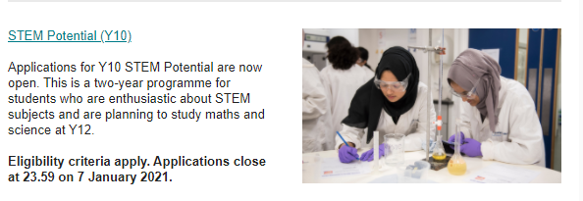

Interest in a career in the Army?

HARROGATE (Army Foundation Centre) VIRTUAL OPEN DAY
Interested in finding out about Junior Entry? The Harrogate Virtual Open Day is the ideal opportunity for you to learn about what training and development opportunities that are on offer at our world-class training facility.
The presentation is on Wednesday 9th December at 6:00 pm and will take place online
Hear from the Commanding Officer, Lt Col Simon Farebrother who will explain what Junior Soldiers can expect from the college, take a virtual tour of our campus, hear from a current Junior Soldier and have an opportunity to ask any questions you may have about recruitment or Army life live to our presenters.
Register here: HARROGATE VIRTUAL OPEN DAY TALK

UCL are currently providing advice and guidance via an exciting programme of virtual activities and online guidance.

Students in Years 7-11 can apply now for UCL Informed Futures events series. They are running separate events for parents and carers as part of this series. They have also just opened applications for UCL Virtual Events. Over the summer UCL published online resources and guidance for students in Year 11. Students can download our free guides from our on website now.

Click here for more information.

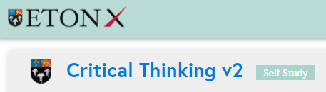

Year 11

Eton College is once again making ONE of its on line self-study courses available free of charge to school pupils in Year 11. The programme that I have chosen for you to complete is on Creative Problem Solving a life skill that employer’s highly value and expect prospective employees to be able to demonstrate.

1. Go to http://learn.etonx.com/ and click ‘Sign Up’
2. Create your account using your school email address
You MUST use your LGFL mail account (eg. <username>.312@lgflmail.net), the swakeleys email will not work
3. Enter your Access Code: 72V2VDRF and click ‘Proceed’
4. Follow the on-screen instructions
5. Congratulations! You can now get started on your course.

Well done to the 31 pupils who have already signed up and started the course. Huge congratulations to the 5
students who have already completed the full course and obtained a certificate!!! 1

Interested in a creative career?

VFX (visual effects) - Meet the Industry.

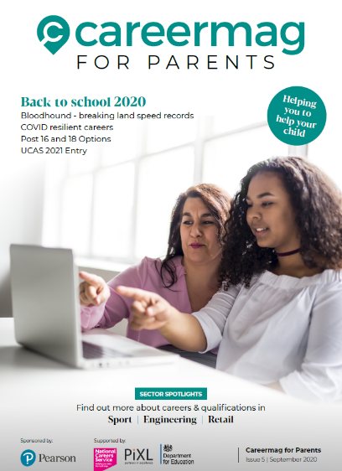

Above are two hyperlinked* resources for you to browse through concerning careers education. One is targeted at parents / carers to demonstrate how they can offer support. The other is designed and written for school leavers from Year 11 through to Year 13.
*Hover over resource and press Ctrl button

For those students considering options outside of Swakeleys School please see below:

https://globalacademy.com/virtual-assembly/

https://www.west-thames.ac.uk/open-day-registration

Useful websites for parents
- The single, most reliable and up to date careers website for all young people (11-19) on careers is https://careerpilot.org.uk/
- A government funded website is the National Careers Service. Its Job Profiles section contains descriptions of over 8oo jobs, with links to more specialist sources of information and guidance.
https://nationalcareersservice.direct.gov.uk/job-profiles/home
- Top website for parents, outlining options and offering sensible careers advice. http://www.parentadviser.co.uk/
- An excellent website with lots of updated information on Apprenticeships http://www.allaboutschoolleavers.co.uk/pare.
- There is also the main Apprenticeship website, government funded, which contains the vast majority of vacancies: Get In Go Far
https://www.getingofar.gov.uk/
https://amazingapprenticeships.com/
https://www.gov.uk/apply-apprenticeship

- Reliable and informative guide to selecting A Level subjects or BTECs, Informed Choices is written by the Admissions departments of all the Russell Group universities
https://www.russellgroup.ac.uk/media/5272/informedchoices-print.pdf
- Reliable information and support for parents with their child’s university applications and the UCAS process generally.
www.ucas.com/ucas/16-18-choices/help-and-support/ucas-progress-parents-andcarers
Useful websites for students
- The single, most reliable and up to date careers website for all young people (11-19) on careers is https://careerpilot.org.uk/
- Not sure what career you want to do? Explore the Job Profiles section of the Careers Service website for accurate information on hundreds of different jobs and Careers TV for video clips.
https://nationalcareersservice.direct.gov.uk/job-profiles/home
http://www.careers4u.tv/explore/
https://icould.com/
- Sign up to this website to explore careers, get the lowdown on top employers, and search for the latest jobs, courses and advice.
https://successatschool.org/
- A dynamic portal of 1000+ open days, tasters, study days and skills events. No registration, no fuss just a brilliantly fast site connecting you to events in seconds www.mystudentevents.com
- A great website offering useful links to information about jobs, qualifications, salaries and advice about CV writing etc.
http://schoolleavers.milkround.com
Research suggests that the majority of careers advice sought by young people is done using the internet rather than speaking with a careers adviser, professional or family member. It is vital that the right information is found.

