Swakeleys Careers News
This page is to provide students and parents with the most up to date information relating to a variety of CAREER NEWS including; work experience, internships, apprenticeships, volunteering, summer schools, STEM opportunities and master classes.
Whilst we are encouraging our students to apply for external courses please note that the organisations offering these activities are entirely separate to the school. Swakeleys School for Girls has not carried out any risk assessments in relation to these activities. For this reason, Swakeleys School for Girls informs you of, but does not endorse, external provider opportunities and will not accept any liability arising from student participation in these activities.
Please remember that we have an independent specialist careers advisor Mr Richard Williams who is available for 1:1 interviews on a Wednesday and Thursday from 8.30am - 3.30pm. Sign up for an appointment on sheet in noticeboard in LRC or the sheet on Mrs Laguillo’s office door.

We now approach our second half term of careers advice and guidance at Swakeleys School. Although there continues to be a lot of uncertainty, one thing is clear: the role of careers education is even more relevant now than it ever has been.
The way in which careers delivery is taking place is rapidly changing and many organisations have chosen to switch their delivery to virtual and online platforms. As a school, we have moved more to making more announcements of current opportunities via Google Classroom.
Well done to all of those pupils who are getting involved and taking up so many of these opportunities!
Current opportunities
Interested in a career in Accounting?

Young Professionals have secured an exclusive event with global Accounting and Professional services firm Grant Thornton.

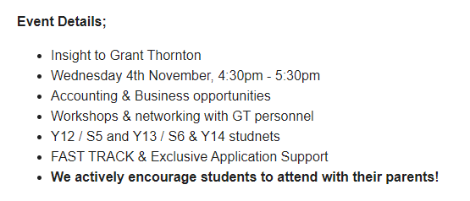

Webinar sign up link!
https://www.surveymonkey.co.uk/r/GTInsightEvent

- What Career Live? & What University Live?

Will be held on Friday 6th November and Saturday 7th November. This will be a virtual event this year and is an ideal event for students aged 15-19 to learn more about their post-school options.
Students can explore opportunities with top employers and leading universities and find out more about the apprenticeship and degree options on offer.
Visitors can:
- Hear talks in dedicated advice theatres
- Get one-to-one advice in the Careers Advice Lounge
-Take part in workshops and activities including Future Skills Workshops

Click here to register and find out more.

UCL are currently providing advice and guidance via an exciting programme of virtual activities and online guidance.

Students in Years 7-11 can apply now for UCL Informed Futures events series. They are running separate events for parents and carers as part of this series. They have also just opened applications for UCL Virtual Events. Over the summer UCL published online resources and guidance for students in Year 11. Students can download our free guides from our on website now.

Click here for more information.

Eton College is once again making ONE of its on line self-study courses available free of charge to school pupils in Year 11. The programme that I have chosen for you to complete is on Creative Problem Solving a life skill that employer’s highly value and expect prospective employees to be able to demonstrate.

1. Go to http://learn.etonx.com/ and click ‘Sign Up’
2. Create your account using your school email address
You MUST use your LGFL mail account (eg. <username>.312@lgflmail.net), the swakeleys email will not work
3. Enter your Access Code: 72V2VDRF and click ‘Proceed’
4. Follow the on-screen instructions
5. Congratulations! You can now get started on your course.

Eton College is once again making ONE of its on line self-study courses available free of charge to school pupils in Year 11. The programme that I have chosen for you to complete is on Creative Problem Solving a life skill that employer’s highly value and expect prospective employees to be able to demonstrate.

1. Go to http://learn.etonx.com/ and click ‘Sign Up’
2. Create your account using your school email address
You MUST use your LGFL mail account (eg. <username>.312@lgflmail.net), the swakeleys email will not work
3. Enter your Access Code: 72V2VDRF and click ‘Proceed’
4. Follow the on-screen instructions
5. Congratulations! You can now get started on your course.

Well done to the 27 pupils who have already signed up and started the course. Huge congratulations to the 4
students who have already completed the full course and obtained a certificate!!! 1

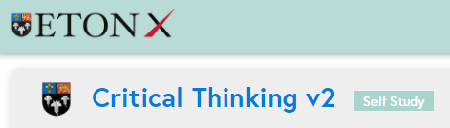

Interested in a creative career?

VFX (visual effects) - Meet the Industry.

A series of virtual events to help 15-18 year olds understand more about careers in VFX, Animation and Games.

Whether you’re artistic, have a passion for maths and programming or have an interest in Business and Marketing, there is a role in the Creative Industries to suit you. Hear from professionals working at PlayStation, Industrial Light & Magic, Union VFX, Moonraker VFX, MPC Advertising, The Mill and more.

Click Here to book tickets

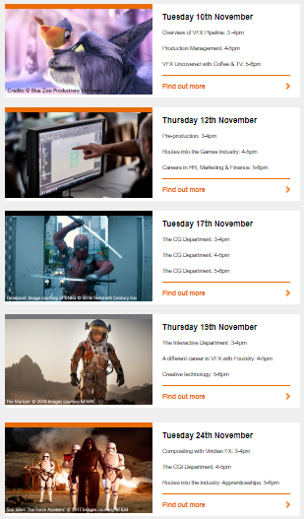

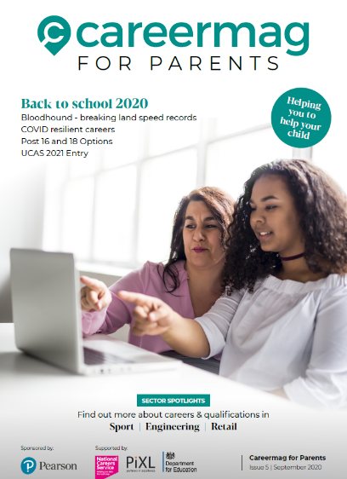

Above are two hyperlinked* resources for you to browse through concerning careers education. One is targeted at parents / carers to demonstrate how they can offer support. The other is designed and written for school leavers from Year 11 through to Year 13.

*Hover over resource and press Ctrl button

This is an excellent website that offers two resources for you to make use of:

- Virtual Work Experience Opportunities. Click here to register.

- Inspirational careers talks.
Click here to see the Vtalks library

With face to face work experience opportunities being impossible to accommodate given the current climate, Virtual Work Experience is the way forward. Get involved!
Useful websites for parents
- The single, most reliable and up to date careers website for all young people (11-19) on careers is https://careerpilot.org.uk/
- A government funded website is the National Careers Service. Its Job Profiles section contains descriptions of over 8oo jobs, with links to more specialist sources of information and guidance.
https://nationalcareersservice.direct.gov.uk/job-profiles/home
- Top website for parents, outlining options and offering sensible careers advice. http://www.parentadviser.co.uk/
- An excellent website with lots of updated information on Apprenticeships http://www.allaboutschoolleavers.co.uk/pare.
- There is also the main Apprenticeship website, government funded, which contains the vast majority of vacancies: Get In Go Far
https://www.getingofar.gov.uk/
https://amazingapprenticeships.com/
https://www.gov.uk/apply-apprenticeship

- Reliable and informative guide to selecting A Level subjects or BTECs, Informed Choices is written by the Admissions departments of all the Russell Group universities
https://www.russellgroup.ac.uk/media/5272/informedchoices-print.pdf
- Reliable information and support for parents with their child’s university applications and the UCAS process generally.
www.ucas.com/ucas/16-18-choices/help-and-support/ucas-progress-parents-andcarers
Useful websites for students
- The single, most reliable and up to date careers website for all young people (11-19) on careers is https://careerpilot.org.uk/
- Not sure what career you want to do? Explore the Job Profiles section of the Careers Service website for accurate information on hundreds of different jobs and Careers TV for video clips.
https://nationalcareersservice.direct.gov.uk/job-profiles/home
http://www.careers4u.tv/explore/
https://icould.com/
- Sign up to this website to explore careers, get the lowdown on top employers, and search for the latest jobs, courses and advice.
https://successatschool.org/
- A dynamic portal of 1000+ open days, tasters, study days and skills events. No registration, no fuss just a brilliantly fast site connecting you to events in seconds www.mystudentevents.com
- A great website offering useful links to information about jobs, qualifications, salaries and advice about CV writing etc.
http://schoolleavers.milkround.com
Research suggests that the majority of careers advice sought by young people is done using the internet rather than speaking with a careers adviser, professional or family member. It is vital that the right information is found.

