1st July 2020
Dear Parents/Carers
First of all, I would like to welcome you to Swakeleys School for Girls as parents/carers of our new Year 7. There are very different times but we are looking forward to welcoming your daughter in September.
Attached are two very important booklets, one for you and one for your daughter. Please read the parents’ booklet very carefully and keep it for future reference. Please read the booklet for pupils with you daughter so that you can discuss any issues raised. I will be contacting you again with details of how to rent a locker and buy a link book and a locker padlock. For the first full week of term, Year 7 will finish slightly earlier at 3pm to avoid the large numbers of pupils at the end of the day. Please be aware that some of our arrangements may be subject to change in the light of government guidance linked to Covid-19.
Please note that uniform must be bought from our sole supplier: W & S Sports, Woodward and Stalder – Orders can be made through their website www.wssports.co.uk Skirts and trousers from other shops and suppliers are not acceptable. The blazer is also only available from W & S Sports. Please make sure that you order the main uniform in good time and by 19th July at the latest. The PE top can only be bought once you know which tutor group your daughter is in as you need to order the correct colour.
If you are experiencing extreme financial hardship and would like to request help with buying some of the uniform, please put a request in writing to me via the school office.
Once again, I look forward to welcoming you to our school.

Yours sincerely

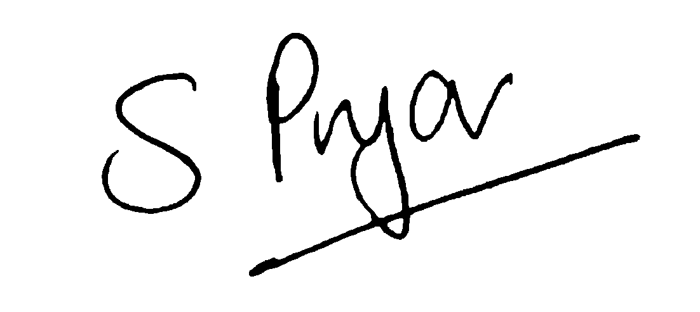

Sue Pryor (Mrs)
Headteacher

