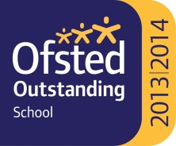

Swakeleys School for Girls is a thriving and successful, multi-cultural school in the London Borough of Hillingdon, with our own mixed 6th Form, offering over 30 different courses. We are over-subscribed, have an excellent climate for learning

Required for September 2020

**Cover Supervisor (full time) Fixed term post for 1 year**

32 hrs per week: 39 wks per year

(term time plus INSET days)

Scale Point 7-10

Actual salary £16,934 - £17,865

The post holder will supervise whole classes during the short term

absence of teachers. The primary focus will be to maintain good order,

to keep pupils on task and ensure effective learning.

The Cover Supervisor will need to respond to questions and generally

assist pupils to undertake set activities. Where cover is not required,

the Cover Supervisor will carry out the usual role of a teaching assistant or

admin/clerical duties as directed.

The closing date for applications is noon on Friday 12th June 2020

Full job description and application form available from the

school website: www.swakeleys.hillingdon.sch.uk

Clifton Gardens, Hillingdon UB10 0EJ

Tel: 01895 251962/Fax: 01895 235027

email: office@swakeleys.org.uk

http://www.swakeleys.hillingdon.sch.uk

Headteacher: Mrs Sue Pryor M.A. N.P.Q.H