


2020-2021

YEAR 7 HANDBOOK

PARENTS
Swakeleys School for Girls
Clifton Gardens
Hillingdon
Middlesex UB10 0EJ
01895 251962
office@swakeleys.org.uk
www.swakeleys.hillingdon.sch.uk
@SwakeleysSchool



July 1st 2020

Welcome to Swakeleys School for Girls! I hope your daughter will be happy and successful here, and that you will be pleased with her progress.

The aims of the school are set out on page 3 of this booklet, and you will see that we want your daughter to achieve her best, be it academically, personally or socially. Habits formed at the beginning of her school career will be crucial in her success. The influence of parents is far greater in this than that of the school - we cannot educate your daughter without your help. I am therefore looking for a supportive, cooperative partnership between you the parents/carers, and us the teachers, as this will be the key to her success and achievements.

Because you have chosen Swakeleys for your daughter, I know you will want to support the aims of the school and its rules and regulations. The information in this handbook is intended to be useful to you in the coming months. If there is anything else you need to know, or if you have any concern about your daughter's progress, please do not hesitate to get in touch with the school.

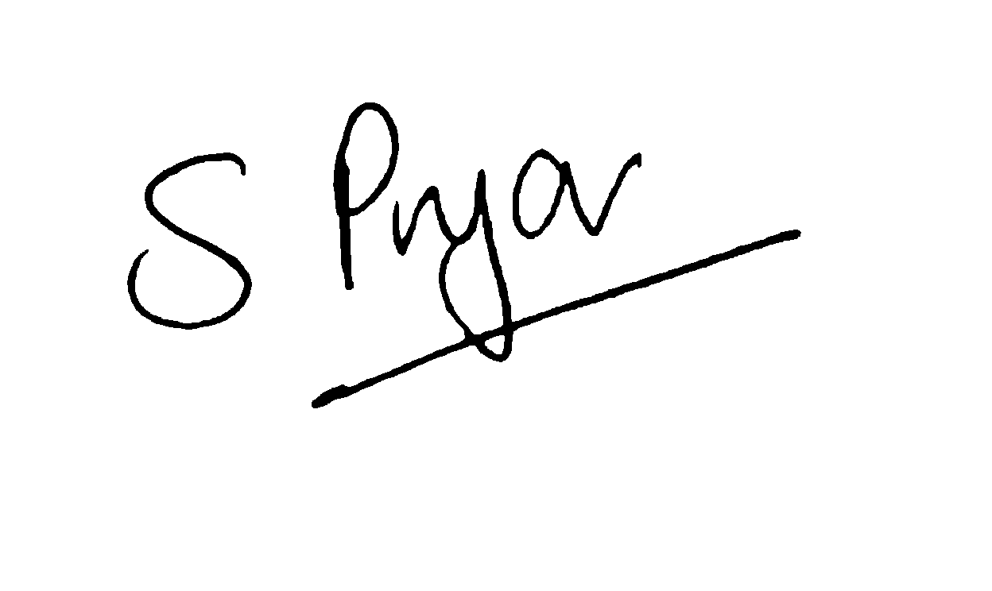

Mrs Sue Pryor
Headteacher

CONTENTS

Page
The Aims of Swakeleys School 3
House Colours 3
Starting a New School 3
Travel to and from School 4
Timing of the School Day 4
Organisation 5
Link Book 5
Lockers 5
School Uniform 6-7
School Organisation 8
School Meals 8
Contacting the School 9
Absence from School 9
Severe Weather Conditions 10
Medical Information 10
Homework 11
Practical Lessons 12
Learning Resource Centre 12
School Council 13
Extra-Curricular Activities 13
School Rules and Discipline 13
Rewards 13
Punishments 14
Zero tolerance 14
Alternative Provision 14
Bullying 15
Theft 15
Parent Pay 15
Guidelines for Care of Personal Property 15
Parents’ Forum 16
Mobile Telephones 16
Sex and Relationships Education 17
Pupils’ Photographs 17
Facebook 17
Medical Form 18
AIMS OF SWAKELEYS SCHOOL FOR GIRLS

- To create a school community based on equal opportunities in which each individual is valued, and where learning will thrive so that girls will gain a sense of achievement from the learning process.

- To provide a challenging and stimulating environment which will enable every girl to achieve the highest level of skills, knowledge and qualification of which she is capable.

- To teach self discipline and a sense of responsibility to self and others and to foster a commitment to excellence.

- To widen the horizons of all our pupils, to make them aware of the rich cultural diversity of our society, and to prepare them for the wide variety of roles open to women in today's world.

- To foster close links with the local community and to be flexible as an institution so as to evaluate and respond to new initiatives, both from inside and outside the school.

HOUSE COLOURS
Swakeleys runs a House System throughout the school, which is both competitive as well as motivational. Girls are allocated to a house through their forms. House names and house colours are as follows:

AF | ANNE FRANK | BLUE
EB | ELIZABETH BLACKWELL | RED
FN | FLORENCE NIGHTINGALE | GREEN
JA | JANE AUSTIN | PURPLE
MC | MARIE CURIE | YELLOW
RP | ROSA PARKS | ORANGE
DS | DIANA SPENCER | TURQUOISE
MY | MALALA YOUSAFAZI | PINK

House points are awarded throughout the year for a variety of events. These can include House Dance, House Sing, spelling the Word of the Week, attendance and excellent corridor behaviour.

STARTING A NEW SCHOOL

Coming to Secondary School means leaving the familiar surroundings of the Primary School for a school several times larger in terms of buildings, pupils and teachers. Since Swakeleys draws on a great number of Primary Schools in each year, your daughter may be the only one from a particular school in her year, or one of many. Some girls find the transition difficult at first, but most of the girls who join us in September settle in very quickly because they have been well prepared for the move to the Secondary School. We would ask you to help your daughter accustom herself to the new routines, so that her first few weeks are as easy as possible.

TRAVEL TO AND FROM SCHOOL

We believe that your daughter should either walk to school, cycle to school or use public transport. This is in keeping with a ‘healthy lifestyle’ and our desire to preserve the environment.

Public Transport - Your daughter will probably be using public transport for the first time, unaccompanied by you. During the summer holiday, you need to undertake a few 'dummy-runs' with her, so that she familiarises herself with the buses/trains she needs to catch and is aware of the approximate length of time required to travel. Your daughter should also know the times at which buses/trains run, and what you want her to do in case of transport problems.

Private Transport – In the case of illness or disability, access to the site by car is of course permitted, by arrangement. If this is the case, you must drive in through the Clifton Gardens entrance, down the drive and drop her at the turning circle. Under no circumstances should you ever drive a car into Pole Hill Road as this causes serious congestion and it is dangerous, both for your own child and other pupils, to have a constant stream of traffic.

Walking to School – Please practise walking the route to school in the summer holiday so that your daughter knows the route and how long the journey takes, making sure that she can arrive in good time.

Cycling - If your daughter has passed her Cycling Proficiency Test and wears a cycle helmet she may cycle to school as soon as she has shown proof of this to our Year 7 Learning Coordinator.

In all cases, parents will be aware of the importance of sound road and traffic sense. Road Safety is a topic which will be dealt with in school periodically, but please ensure that your daughter understands and is able to apply the rule of the road.

TIMING OF THE SCHOOL DAY

If your daughter arrives at school before 8:30, she must go straight to the Canteen or the Hall and remain there until the bell goes at 8:30. Students must be in their form rooms for Morning Registration by 8:40.
Girls who are late will be issued with a zero-tolerance detention.

ORGANISATION

Perhaps for the first time in her life, your daughter is responsible for everything she needs for the school day and this can involve many items. It is important that she establishes a set routine and that she learns to organise herself. She will need help and support from you in this, especially at first. For instance, everything required for the school day needs to be ready the previous evening. Your daughter will need a strong, waterproof bag to carry her equipment and books to and from school.
ESSENTIAL EQUIPMENT
- Ruler
- Protractor
- Colouring and ‘lead’ pencils
- Ballpoint pens (only black, blue, green, no other colours)
- A fountain pen and spare blue or black ink cartridges
- A pair of compasses
- Pencil case
- Rubber
- Pencil sharpener
- The Pupils' Handbook
- A pocket dictionary
- A basic calculator
- Glue stick
- Scissors (blunt ends)
- A small plain dark-coloured over-the-shoulder bag for money, keys etc
- A black whiteboard pen (dry wipe)
We do not allow Tippex correcting fluid.

LINK BOOK

Every pupil is issued with a Link Book which we ask you to look at every day and sign every week. The cost of the Link Book is £5 and payment must be made via Parent Pay. You may write or receive messages from staff so please check it regularly. There is a page at the back where your daughter will list all letters issued by the school. This page also should be signed. Your daughter must look after her Link Book. We do not permit graffiti.

LOCKERS

Girls will be given the opportunity to hire a locker to use during their time at Swakeleys. This will cost £10 for the year which includes £5 to cover the cost of a combination lock provided by the school. Payment for the locker must be made via Parent Pay. The locker should be used to keep her books and personal belongings secure. Everything should be clearly marked with your daughter’s name.

SCHOOL UNIFORM
Years 7 - 11
- Grey Swakeleys School for Girls Blazer*. Black knitted, v-necked jumper with one emerald green stripe in the ‘V’.
- Plain black A-line or pleated school skirt; no more than 3 inches (8cms) above or below the knee. (Not clinging lycra or skirts with slits). For Year 7-9, there is a compulsory standard double pleat skirt available from W and S Sports.
- Plain black straight leg, loose fitting school trousers with no buckles/other fashion accessories or visible labels. No stretchy material. Not hipsters. For Year 7-9, there is a choice of two styles of uniform trouser that are compulsory and are available from W and S Sports.
- Plain green polyester-cotton blouse with collar, long or short sleeves.
- Socks should be black or white/natural or black tights with no designs or patterns.
- Black low-heeled formal shoes (no more than 1 inch /2cm – not stiletto heels/platform soles/clogs/ankle or knee length boots/or any ‘sling back’, backless or open toed shoes). Shoe laces must be black. No trainers or canvas shoes. Shoes must be leather/leather look and without fashion accessories or embellishments. .
- A warm, practical coat in navy or black. No logos or patterns. No hoodies or sweatshirts with hoods.
- Sandals and no socks if the weather is hot in the last half of the academic year. (Sandals must be black or white, but not slip on).
- Make-up is not permitted in Years 7-9. This includes foundation, mascara and eyebrow enhancement.
- Hair must be a natural shade/colour and extreme hair styles are not permitted. The headteacher will make the final decision on what constitutes “extreme”.
- Light foundation and natural looking mascara may be worn in Years 10 and 11.
- Nail varnish and false nails of any kind are not permitted.
- Hair accessories must be understated and black, white, green, gold or silver. They should not be decorative .e.g. with large flowers, patterns.
- Any girls who needs, for religious reasons, to wear a headscarf may do so (except for PE) as long as it is plain white, black or emerald green with no embellishments. Hair grips should be used as fasteners. No pins are allowed.
Year 11
- As above except the green shirt should be substituted for white.
*If a blazer is worn, the wearing of a school jumper is optional. All pupils are required to own a school jumper as this will be needed in colder weather.

P.E. - All years:
- House Colour Aertex shirt (essential – you will not be able to purchase this until your daughter finds out what form she is in so that you can buy the correct colour).
- Plain black football style shorts (essential)
- White football-type knee-length socks (essential)
- Lace up running trainers with non-marking soles; if unsure check with the PE department before purchase (essential).
- Football boots (optional)
- Black tracksuit/jogging suit (optional)
- A change of clean socks is essential, as feet get wet during games lessons.
- Girls who wear a headscarf for religious reasons should wear a black elasticated sports headscarf that does not go around her neck. During the summer term when we are outside your daughter will be allowed to wear a scarf that covers her neck but it must still be a plain, sports designed tight fitting one.
- All jewellery must be removed for PE lessons.
- Black round-neck Swakeleys School sweatshirt (optional)

Our approved suppliers are:-
W & S Sports, Woodward and Stalder – Orders can be made through their website www.wssports.co.uk

The only jewellery which may be worn to school is:
- A watch
- Plain round ear-studs (gold/silver or clear) if a girl has pierced ears (one set only). They must not exceed 5mm diameter and must be worn at the bottom of the ear.
- One plain ring (large signet rings and sovereign rings are not permitted for safety reasons)
- Religious jewellery e.g. cross on a plain chain (tucked inside the shirt) or a Kara (Sikh) bangle.
- A nose stud. This must be small, plain gold/silver or clear and discreet and is
worn at the owner’s risk. No other forms of body piercing are allowed.
No other jewellery is allowed; if worn, it will be confiscated.
No other piercing of any kind is permitted.
- Confiscated jewellery is put in a sealed envelope, signed by teacher, taken to the school office and then placed in a secure cabinet until the end of term or until collected by a parent.
- Parents should give the School Office 24 hours notice before coming to collect jewellery.

Please note that the school uniform includes the school ID card and lanyard which should be worn at all times. Girls who break uniform rules will be issued with a zero tolerance detention.

The Welfare Assistant will have a reserve of clean items of school uniform which girls will be asked to borrow if, for any reason, their own uniform is unwearable or inappropriate.

SCHOOL ORGANISATION

On entry next September, your daughter will be placed in a mixed ability tutor group. Her Form Tutor will see her in the morning for registration in her tutor room, and may also teach her. For each subject on the curriculum, your daughter will have a different specialist subject teacher for each lesson. There is some setting in Year 7, and girls who experience significant learning difficulties will be given extra support. Year 7 pupils are carefully monitored to assess the most suitable provision for their learning in the following years. Miss Allan is the Year 7 Learning Coordinator and she co-ordinates the work of the Form Tutors, assemblies and other activities. Your daughter's Form Tutor is the person who has the greatest part to play in her day-to-day welfare.

SCHOOL MEALS

We operate a cafeteria system in the School Canteen. Pupils have a choice of hot meals, cold meals or snacks.

- Breakfast is available from 8:00 – 8:30.
- At morning break, drinks (hot or cold) and snacks are available.
- Pupils may buy a school meal or bring a packed lunch for their midday meal.
- About £3.50 should suffice to buy a snack during break time and a balanced midday meal.
- Pupils bringing a packed lunch may, of course, supplement their meal by buying a drink or a snack.

Our canteen operates a cashless system where meals must be paid for via “Parent Pay” in advance. Full details of your daughters’ account will be given to her on her first day at Swakeleys. Pupils must bring a packed lunch for the first week until Parent Pay is operational.

None of the sandwiches we order in contain nuts and all are clearly labelled. We do not use any items containing nuts in the hot food service, if we have treats we do display a sign clearly showing that traces of nuts may be present but we mainly choose treats that are nut-free due to allergies. Our policy is that we do not use nut-based products.

We also advise parents not to use nut-based products in the packed lunch they provide to their daughters.

Food may not be eaten in classrooms or corridors. Pupils may eat in the Canteen in the Hall or outdoors during warm weather in the designated picnic area.

Pupils must remain on the school site.

If there are any changes in your daughter's lunchtime arrangements you need to inform the Year 7 Learning Coordinator in writing.

CONTACTING THE SCHOOL

A close partnership between home and school is valued and an important element in your daughter's progress and development. We encourage contact between parents and school, and ask you to let us know of any problems and worries. Please telephone on 01895 251962 between 8:30 and 4:00, if you wish to make an appointment. This will be with the Year 7 Learning Coordinator in the first instance.

If coming in person to the school, parents need to sign in at the Reception Office, and for reasons of security and Health and Safety, must be accompanied by a member of staff in all parts of the school.
These are some of the people you may need to contact:

Mrs S Pryor Headteacher
Mrs G Hare Deputy Head – Behaviour and Safety
Mrs C Devereux Deputy Head – Achievement
Miss O Wall Deputy Head – Teaching and Learning
Mr L Hepner Assistant Headteacher
Mrs P Laguillo Assistant Headteacher
Miss S Hanlon Assistant Headteacher
Dr K Laxton Head of Inclusion
Miss H Allan Year 7 Learning Coordinator/Transition Coordinator
Miss K Parker Attendance and Home School Liaison Officer
Mrs J Thompson Welfare Assistant

REMEMBER TO LET THE SCHOOL KNOW IF YOUR CONTACT DETAILS CHANGE.

ABSENCE FROM SCHOOL

Regular attendance is a key factor in success at school. Please ensure that your daughter does not miss any schooling unless it is absolutely necessary. Pupils should aim to be in school as close to 100% of the time as possible. Pupils with less than 95% attendance are a cause for concern and action will be taken to achieve higher attendance.

The Law now states that no holidays should be taken during term time in a school year.

Please also note that as an oversubscribed school we will not hold a place open for a girl who is absent for more than 4 weeks (except on medical grounds). If there are exceptional circumstances which mean your daughter will be absent from school for more than 4 weeks you must contact Mrs S Pryor Headteacher. Prolonged absence without permission can result in the pupil being removed from the school roll.

Dental and medical appointments during school hours should be avoided if at all possible. For dental appointments, cards should be shown to the Form Tutor the day before.

If your daughter is unwell please ring before 9:00am and leave a clear message on the Attendance Officer’s answer machine including your daughter’s full name and form and reason for absence. The number is 01895 251962 ext 127. If your daughter is absent and we have not heard from you and she has not signed in late, then the Attendance Officer will trigger ‘truancy call’ to obtain a reason for your daughter’s absence.

When you supply a reason for absence, the Attendance Officer will adjust the marks in the register accordingly. It is good practice to follow this up with a letter to your daughter’s form tutor on her return.

While we do encourage everyone to attend school, it is obviously unwise for girls to come who have heavy colds, or who are suffering from vomiting or a temperature. You, as parents, know when your daughter is genuinely unwell or when she is "trying it on”! Our Welfare Assistant is also experienced in differentiating between those who are really unwell and those who feel like a rest from lessons. The Welfare Office is only there for genuine cases of ill health and accidents, otherwise girls are quickly returned to the classroom.

Please encourage your daughter to have a good breakfast. Many girls complain of feeling 'unwell' and 'faint' and when questioned, it is discovered that this is due to hardly any or no breakfast at all. No one can work well (or play well) on an empty stomach! Remember breakfast can be purchased in the canteen.

Should your daughter need to leave school in the course of the school day, she must sign out with the Welfare Office or at the Reception Office, and sign in if she returns the same day.

SEVERE WEATHER CONDITIONS

If the weather is unusually bad, for example if there is heavy snowfall, please consult our website, www.swakeleys.hillingdon.sch.uk which will give information as to whether school is open or not. This information will be updated daily at 7 am until the severe weather conditions have ended. You can also telephone 0208 408 7508.
MEDICAL INFORMATION

In the Admissions Booklet, there is a form for you to provide detailed medical information about your daughter, so that we are able to help with any physical disabilities and cope with any emergency should she be ill while at school.

We are only able to administer medication that has been brought into school in original packaging and with specific written instructions on the school form. This includes the administration of painkillers. Any pupil who wishes to leave medication with the medical room may do so but it must be accompanied by the ‘Medication to be held in school’ consent form. Attached to this handbook is a form that can be returned to school with such medication. This form will also be available on the school website for use with any future medication needs.

You are also asked to provide contact telephone numbers in case of an emergency during the school day. If you are not on the telephone at home it is essential that you provide us with the number of a relative or neighbour who can be contacted and who will pass on information to you. Please remember to let us know if your contact details change.

Asthma
All asthmatic students must ensure that they carry an inhaler and spacer at all times and that this is easily accessible in their bag and taken to PE and any other special events when they may not have a bag with them.

Students are no longer required to bring a second inhaler to store in the Student Services. This is because the school now holds emergency inhaler kits which can be used in the case of an emergency. It must be stressed that these are not for everyday use. If a pupil has to use the emergency inhaler because they do not have their own, parents will be invoiced for the cost of a replacement.

First Aid
Our Student Services is for first aid only. If your daughter requires any other type of care or advice please take them to your GP or telephone 111 for advice.

Health Plans
All pupils who have a long term condition must have a health plan. This is so we can understand the care your child needs. If you think your child requires one please make an appointment with Mrs Thompson.

Medication
Any students wishing to keep medication or painkillers in the school in the Welfare Office must bring in the Medication Form. This can be found at the back of this booklet and on our website. A letter is not acceptable.

HOMEWORK

Regular completion of homework is an essential part of the learning programme. It gives both pupils and teachers the opportunity to see whether the work done in class has been properly understood. It also develops the ability to work independently, as well as fostering a sense of responsibility for work and progress.

At the beginning of the school year, a homework timetable is issued and each girl has a Link Book in which to record the homework set. This homework section helps the pupil organise herself, and is also a link between school and parents. We need you to sign this once a week and note any comments from teachers. You may add comments when applicable.

Pupils vary in the speed at which they work, but during the first year, homework set will not normally be more than one and a half hours each day.

Your daughter will need to organise her time carefully and your support in this is essential if she is to form good study habits and succeed in her work. If at any time your daughter appears to be doing too much or too little homework, please contact her Form Tutor or Miss Allan, Year 7 Learning Coordinator. We run an after school Homework Club supported by Teaching Assistants and with access to computers. Letters with a permission slip are issued in the Autumn Term.

Obviously homework should be done at home and is best done on the day it is set, while classwork instructions are still fresh in the mind. It should certainly not be rushed in the lunch hour, nor in the few minutes available before school starts.

PRACTICAL LESSONS

Design and Technology

In order for your daughter to experience all aspects of the design and make process we supply all necessary resources at school as it will enrich the curriculum as well as removing the need for you to purchase expensive paints and such items.

We do however ask for any donations for the Textiles Department, we are always looking for items that you may be about to throw out or no longer have a need for, such as threads, fabrics, buttons and such items that will help pupils with their projects.

Food Technology

Plastic aprons are supplied by the school; girls may bring their own if they wish.
Ingredients: one week's notice is given of what is required for each practical lesson, and girls are expected to bring the ingredients. Normally they cook enough for two to four people only, because of the cost and the limited time available. A vegetarian alternative is always given.

If you have any difficulty about providing ingredients, please send a note to the teacher before the day of the lesson, so that alternative arrangements can be made for your daughter.

LEARNING RESOURCE CENTRE

Swakeleys School for Girls Library/LRC has over 7000 books and is used by Years 7 – 11. There is a separate library for Years 12 & 13 in the Sixth Form @ Swakeleys Centre. It is a quiet, comfortable area where pupils can read, research and do homework. There are computers, easy chairs and desks for pupil use at break times and also for timetabled lessons. The librarian is helped by a team of enthusiastic pupil librarians who are invaluable to the successful running of the Library.

In September, each Year 7 class receives induction from the librarian, through a presentation, talk and worksheets. Pupils use their Identity card to loan 4 books for three weeks and there is a fine on overdue books of 5p per day per book, capped at £2.00.

OPENING TIMES
The Library is open at various times throughout the school day and every day after school until 4.30 except Friday when it closes at 4pm. It is open Monday and Wednesday lunchtime from 12.30 for Year 7.

Events include book fairs and competitions. There is also a successful Year 7 Reading Club which focuses on the Hillingdon Book of the Year Award.

SCHOOL COUNCIL

Swakeleys has a very active and effective School Council, which through its various committees tries to provide suggestions for improving the school. The ideas come from the girls themselves, who also report back on issues that affect them.

EXTRA CURRICULAR ACTIVITIES

Swakeleys School runs a wide range of lunch-time clubs and after-school activities which form an important part of the wide curriculum offered at the school. Girls are encouraged to participate and it is expected that, once they have decided on their activity and/or have been chosen to represent the school in such things as team games, they attend any practices, rehearsals, school outings as required. It is important to learn early on that other people's success and enjoyment depends very much on a team effort, and we hope that you will support your daughter in her commitment to our programme of extra-curricular activities.

SCHOOL RULES AND DISCIPLINE

Our school rules are designed to encourage self-discipline and consideration for others. The School Student’s Contract is in the Link Book. There are some important points, however, in which parents are particularly asked to co-operate:
- Girls should attend regularly and punctually, wearing correct school uniform and outer clothing appropriate to the weather.
- Jewellery and other valuable items must not be brought into school. Any girl who needs for some reason to bring money in, should hand it in to the Reception Office for safekeeping. The Governing Body can accept no liability for loss of, or damage to, personal possessions.
- Behaviour, attendance, punctuality and homework are carefully monitored. Where there is cause for concern in any of these areas, or where there is a serious infringement of school rules, parents are contacted and the girl may be put "On Report". In extreme cases a girl may be suspended from lessons through Alternative Provision.
- Chewing gum is not allowed in school. If caught, pupils will be given a zero-tolerance detention.
- Aerosol sprays are not allowed and will be confiscated.

REWARDS

Services to Tutor Certificates: Girls in Year 7 who are helpful to their form tutors receive certificates.

Merits: Girls in Years 7-8 who do a particularly good piece of work, either in class or at home, may be awarded a merit by their teacher. Certificates are awarded when a certain number of points is achieved.

Distinctions: Outstanding achievements in school work are rewarded with a Distinction Certificate presented by the Headteacher in Assembly and which your daughter will bring home. A trophy and certificate are awarded each term to the tutor group that gains the most Distinctions.

Commendations: Girls are awarded Commendation Certificates for service to the school. These are presented in Assembly and your daughter will bring them home.

Attendance Certificates: These are awarded to girls with exceptional attendance records. A trophy and certificate are given to the tutor group with the best attendance record for the term. We run a number of incentives for excellent attendance including non-uniform days and prize draws.

Other rewards are also presented to girls. Please see ‘Swakeleys School Behaviour Policy’.
Please encourage your daughter to keep her certificates in a safe place so that she can incorporate them into her Progress File.

PUNISHMENTS

Detentions: Girls who persistently infringe school rules, or who do not complete homework, will be kept in detention from 3.20 for between 20 minutes and up to an hour. If this happens, you will be informed in writing, phone or by text on the day before the detention, (legislation states that the school is not required to seek parental permission to issue a detention but does need to give 24 hours’ notice for detentions of more than ten minutes). Lunchtime detentions are also given on occasion for no equipment/kit, to make up work not done and for zero tolerance infringements. It is sometimes necessary to detain a pupil for up to ten minutes after school to speak to her about a school matter; a pupil will not normally be detained for longer than this without notifying you.

ZERO TOLERANCE

Please be aware that the school operates a zero-tolerance policy for the following:
- lateness
- uniform infringements, including not wearing lanyards
- chewing gum
Students arriving late to registration and/or to lessons, wearing the wrong school uniform or chewing gum will be issued with a zero-tolerance detention at lunchtime of the following day.

ALTERNATIVE PROVISION

For very serious misconduct, a pupil will attend school but will not be allowed to enter the main school building. She will complete work set by her teachers in our Alternative Provision Room under supervision of our Alternative Provision Room Manager. She should be in school uniform and bring a packed lunch (or if Free School Meals her lunch will be brought to her). There is a toilet in the Alternative Provision Room. Should this be necessary for your daughter, you will be notified by telephone and by letter. In some instances you will need to accompany your daughter to meet, by appointment, Mrs Pryor, Headteacher, Miss Hanlon, Assistant Headteacher (Behaviour and Safety) and Miss Allan, Year 7 Learning Co-ordinator, to consider her readmission into school.

BULLYING

Bullying is persistent unfair treatment through action or words, by an individual or group which is meant to make others feel miserable or worthless. At Swakeleys we believe that everyone has the right to enjoy their learning and leisure free from intimidation. Bullying will not be tolerated. It is everyone's duty to report bullying whenever and wherever they see it. We are a 'telling' school. Bullying is too serious to suffer in silence. Any girl who feels she is bullied should either tell her Form Tutor or one of our trained pupil SWAB counsellors.

THEFT

At Swakeleys we do our utmost to prevent theft. However, we recognise that occasionally it happens. Together with the girls we have drawn up guidance for the care of personal property, which we would like you to read with your daughter.

PARENT PAY

Parent Pay is an online payment facility used by the school. It is a quick and efficient way of making payment for your daughter’s school lunches and educational visits. The benefits to parents are that money is not lost or mislaid on the way to school and that you can make your payment at any time from wherever you are. All major credit cards and debit cards are accepted.

Access to Parent Pay is via the website www.parentpay.com and your daughter will be provided with a unique username and password upon admission to the school.

GUIDELINES FOR THE CARE OF PERSONAL PROPERTY

WHAT PUPILS SHOULD DO:
- Keep items of great financial or sentimental value, and large amounts of money at home.
- Name every item that you may have to leave unattended eg bag or coat. With coats use a permanent marker and write your name in an unusual as well as obvious place, eg inside the pocket or down the sleeve. Leave your coat in your locker unless you are going outside. Use security marking on mobile phones and SIM card.
- Be responsible for your own property. Never leave valuable items such as purses or mobile phones in an unattended bag or coat, not even for a minute. If you have to leave the room for any reason ask a friend to keep an eye on your bag until you return or take your valuables with you.
- Keep your coat and bag locked in your locker at break or lunchtime unless you are going outside.
- If you see anyone behaving suspiciously, make it obvious that you are watching her if you feel able to do so. This can be enough to make her stop.
- Always report anything suspicious to a member of staff. This is not telling tales or ‘grassing up’, it is behaving as a responsible citizen. Think about how the victim will feel if you let someone get away with stealing her property.

WHAT THE STAFF WILL DO:
- Provide lockable lockers for every pupil who wants one. If yours does not lock tell your form tutor who will report it to the Premises staff for repair.
- Be on duty at break and lunchtime and check the corridors and toilets regularly.
- The Reception Office staff will look after large sums of money for you until 3.30 if you have to bring them into school for any reason.
- Make every effort to trace stolen property. This is made much easier if the item is named.
- Please see the separate section on mobile phones.

REMEMBER sometimes people report items as stolen when they have simply mislaid them or left them at home. Always retrace your steps first, check with the Pupil Welfare Office, the School Office staff and the Premises staff to see if a lost item has been handed in. If you do find it at home or school please let your tutor or Year Learning Coordinator know.

PARENTS’ FORUM

Parents’ Forum meets every half term and offers parents the opportunity to meet with the Headteacher to discuss important issues regarding the running of the school, to offer support and to contribute their own ideas. Dates of forthcoming meetings are published on the school website and we would like two representatives from each tutor group. Parents interested in joining should contact the school office at office@swakeleys.org.uk.
MOBILE TELEPHONES

Serious problems arise by students having mobile phones on school premises. These include:
- theft and loss of mobile phones
- disruption to lessons
- concerns relating to the personal safety of girls who are seen carrying phones to and from school
- staff time spent dealing with incidents relating to mobile phones.

Lockers are provided to all pupils and the responsibility for personal property, including mobile phones, remains with pupils. They are expected to secure their locker with an appropriate padlock.

Any girl whose mobile phone is seen or heard by a member of staff during the school day (including break and lunch time) will have her phone confiscated and placed in the school safe. The confiscation will be logged on SIMS and this information sent to the Mrs Hare and the pupil will receive a 1 hour LG detention.

The school day is defined as 8.30am until 3.20pm or 2.15pm on Tuesdays. The definition of the school day would also include any attendance at clubs, activities or detentions that may extend beyond this time.

If this happens a parent can collect the phone from the School Office at the end of the day during office opening hours. The school office is open 8.00am-4.00pm. The school will not contact parents on this matter.

If a parent is unable to collect the phone from the school office then the phone can be collected by the pupil at the end of the following school day. Phones will be available for collection from 3.20pm during office opening hours.

In cases of pupils who persistently break the rules relating to mobile phones the school reserves the right to retain the phone for a longer period of time.

Any pupil who has broken this rule on three or more occasions will be required to arrange for their parents to collect the phone in person or it will be retained until the end of the school week when it can be collected by a pupil.

The Governing Body can take no responsibility for mobile phones brought into school, and staff will not investigate any incident of the loss of or damage to a phone.

If you need to contact your daughter during the school day you should telephone the School Office.

SEX AND RELATIONSHIPS EDUCATION

Year 7 pupils will be taught the following topics to meet the Government requirements of Sex and Relationships Education:
- Feelings and emotions, friendship and relationships
- Personal care
- Puberty talks
- Basic skills in ‘opening up’ and maintaining these skills

These topics will be taught as part of PSHE and Citizenship Curriculum lessons. If you wish to see or discuss the specific details of these topics please telephone Miss H Allan, Head of PSHE.

PUPILS’ PHOTOGRAPHS

From time to time photographs of pupils may be taken and used in display work, publications in local newspapers, prospectuses, Link Book, on Fronter and on the school website. For examination purposes videos may also be made of pupils.
At Swakeleys we understand that parents may be anxious about the use of images of their daughters, so we would be grateful if you would indicate whether you give your permission on page 9 of Section 1 of the Admissions Booklet.

FACEBOOK and INSTAGRAM

It is illegal for a person under the age of 13 to register with Facebook or Instagram. Please ensure your daughter does not break the law by registering with Facebook or Instagram before her 13th birthday.

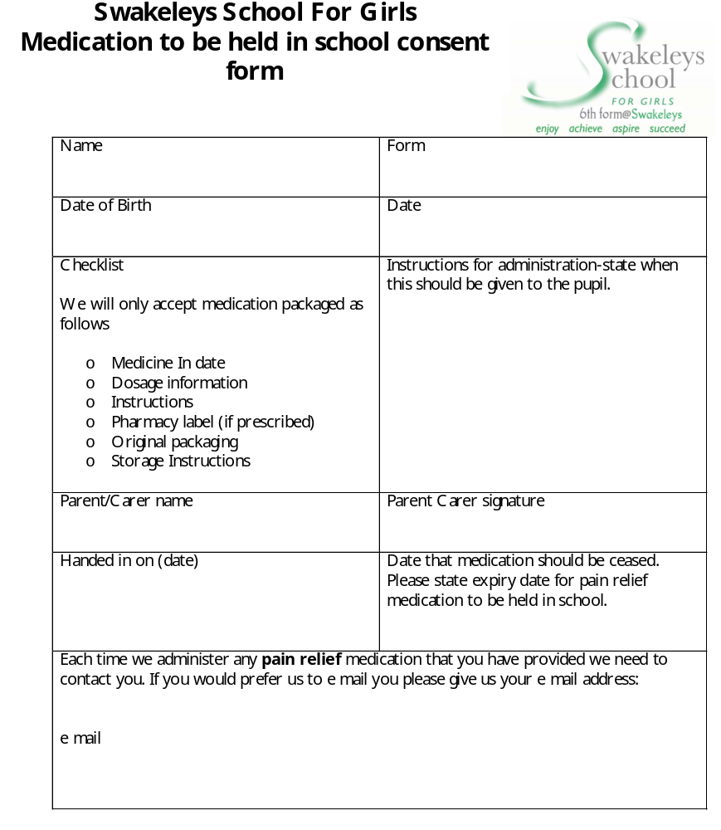
-No child under 16 must be given medicine containing aspirin in school unless prescribed by a doctor.

-Maximum doses for pain relief medication must be checked and when the previous dose was taken.

-Parents must be informed when pain medication is administered.

