BEHAVIOUR POLICY
Rationale
The purpose of this Policy is to summarise the way in which Swakeleys School for Girls rewards positive behaviour and the sanctions which are put in place following poor behaviour.
The behaviour policy will apply to students during the school day, on all school trips and events, on travel to and from school and at any time the student is wearing the uniform of the school. Where the behaviour policy is breached at other times and impacts on the education or wellbeing of students in the school the behaviour policy may still be applied.
Acceptable Behaviour
Can be defined
Includes respect for others
Includes listening to and responding to teachers
Includes choosing to avoid conflict with others

Above all it means students accepting responsibility for their own actions and ensuring that they do not adversely affect the education of others.
Our behaviour policy is based on the premise that:
Every student has the right to learn.
Every teacher has the right to teach without interruption.
Every parent has the right to information about their child’s behaviour and to work in partnership with the school to encourage high standards.
Pupils represent the school beyond the school day through their physical presence and their presence on social media.
Partnership
Our behaviour policy is a partnership between staff, students, parents and governors and all participants in this partnership need to be aware of our standards.

REMEMBER
The more serious consequences and sanctions are for the minority; the praise and rewards are for the majority.

Objectives
The objectives of the policy are to:
Clarify what is meant by “good behaviour” to all members of the school community.
Encourage a positive learning environment where students behave well towards each other and all staff, and where effort, hard work and good behaviour can be rewarded.
Ensure that staff present themselves as good role models and provide lessons that are well planned, relevant, appropriate to the ability of the students and contain high level of challenge and interest.
Engage purposefully with parents and work with them to support their daughters.
Ensure that lessons are inclusive and take account of the ethnic and cultural diversity of all students. At Swakeleys the clear link between effective teaching and positive behaviour is recognised.
Ensure that all staff motivate their students by using a variety of rewards to recognise good behaviour, as individuals and as a whole class, in a structured way.
Ensure that all staff have an important role to play in encouraging good behaviour.
Ensure that students, staff and parents have a clear understanding of the consequences of misbehaviour.
Encourage each student to value themselves and their own effort, their class and their school, so that they grow socially, personally and academically.
Methodology
- Rules
Students are entitled to be taught in classrooms free from disruption and to be able to walk around the school free from intimidation. The school has three simple golden rules to which students must adhere. They are displayed in the classrooms.

THREE GOLDEN RULES
- Do as you are told, when you are told, at the first time of asking.
- Listen in silence when others speak.
- Keep hands, hurtful comments etc to yourself.

Students are expected to follow our classroom and corridor rules at all times.
The Classroom Code is displayed in each teaching room:
KEYS TO SUCCESS
Classroom Code
- Be on time for lessons.
- Take books out straight away and put bags on the floor (where appropriate).
- Remain seated unless the teacher asks you to move.
- Contributions are valued in lessons. You should raise your hand and wait for the teacher to respond.
- Listen carefully and follow the teacher’s instructions without argument.
- Put your hand up and ask if you don’t understand.
- Follow all safety rules, including not eating, drinking or chewing gum.
- Treat all equipment and furniture with respect.
- Bring your link book and all necessary equipment and books for the lesson.
- Remain focused and on task in all lessons.
- Pack away when your teacher tells you and wait to be dismissed.
- Leave the room tidy.
The Corridor Code is displayed around the school
Quickly, quietly, considerately.
Students are expected to walk on the left. They should not gather in stairwells and should not raise their voices, particularly on stairs and balconies.
- Responsibility
Good behaviour does not happen by accident. It is the responsibility of all those concerned with the school – parents, staff, students and governors – to ensure good behaviour.
Staff responsibilities are to:
Treat all students fairly
Raise the self-esteem of all students and develop their full potential
Provide challenging, interesting and relevant lessons appropriate to the age and ability of all students
Create a safe and pleasant environment
Use rules and sanctions clearly and consistently
Form good relationships with parents and students and
Have good classroom control
Communicate in a timely way with parents following enquiries to the school.

Student responsibilities are to:
Work to the best of their ability and allow others to do the same
Treat others with respect
Obey the instructions of school staff
Take care of property and the environment in and out of the school
Co-operate with other students and adults
Complete work in class and homework to the best of their ability
Wear the Swakeleys uniform at all times during the school day and on the journey to and from school
Attend school and to arrive on time
Maintain good relationships within the school community through responsible use of mobile phones and social media.
Behave as a responsible student on school travel

Parent responsibilities are to:
Support the Swakeleys School Behaviour Policy
Share concerns about their child’s education, welfare and behaviour with the school
Take an interest and help in their child’s work and achievements
Attend Parents’ Consultation Evenings and support school functions
Support the school in achieving a minimum 95% attendance rate for their child
Inform the school of any absence on the first day
Ensure their child arrives at school, on time
Ensure their child is in full school uniform and is correctly equipped for lessons.
Check and sign their child’s link book on a weekly basis.
Ensure their child completes homework to the best of his/her ability and hands it in on time.
Ensure that their child has a responsible online presence and take appropriate action to safeguard their online actions.
Respect
Staff, students, parents and governors are all entitled to be shown respect by the other participants in our partnership.
- Rewards
At Swakeleys School we believe that students learn through praise, reward and celebration of achievement.
There are many ways in which students are rewarded for good work and behaviour:

Reward | Criteria for Awarding
Verbal Praise | Positive reinforcement for good behaviour, following instructions, good answers.
Positive note in link book | Further positive reinforcement for above.
Good news card | Sent to inform parents about special achievement in behaviour/work.
Commendations | For service to the school eg sweeping the hall, helping on parents’ evening.
Merits | For good pieces of work and effort.
Headteacher’s Distinctions Years 7-11 | For outstanding pieces of work.
Learning Credits | Significant learning having taken place.
Attendance Certificates | High percentage of attendance.
Sponsored Awards | Discretionary
Other School Awards | Discretionary
House Points | For a variety of achievements including, uniform, attendance, literacy, corridor behaviour and making a contribution.

Commendations (Years 7 – 11)
Commendation certificates are presented in Year Assemblies for good behaviour and service to the school.
Merits (Years 7 – 8)
Merits are awarded via e praise and students receive a certificate each term detailing the number of merits they have received.
Distinctions (Years 7 – 11)
Outstanding work is recognised by the awarding of a distinction certificate. This can include practical work.
Learning Credits (Years 9, 10 and 11)
Students are awarded Learning Credits for excellent achievement in a particular piece of work. These are recorded on e praise and students receive a certificate each term detailing the number of learning credits that they have received.
Student Rewards (Years 12 and 13)
Students are awarded points through e praise.
Attendance Certificates
Attendance certificates will be awarded to students as follows:
A Gold Certificate for those who achieve 100% attendance in a whole term and in a full year.
A Silver Certificate for those who achieve above 97% (i.e. no more that two days absence per term) where the absence has been due to religious or unavoidable medical or orthodontic appointments where no choice of appointment time is given by the practitioner concerned.
A Bronze Certificate for greatly improved attendance.

Sponsored Awards
Jack Petchey – for outstanding progress and citizenship
School Achiever of the Year – for student who has achieved the highest level of attainment
Di Marco Science Award-for progress in Science.

Other Swakeleys Awards
- Sports Personality of the Year
Nominations for this are put forward by students, and the whole school votes to select the Sports Personality of the Year. The winner has a framed photograph and synopsis of achievements displayed in reception and is presented with a certificate, shield and sports voucher in school council.
- Termly Form Award
A certificate will be awarded to the form with the best attainment and attendance.
- Other Subject Awards
Celebration Evening Awards
Attainment and Effort Year Group Awards

- Consequences
Students of Swakeleys School represent the school while in school during the normal school day, on educational visits of any kind, and on journeys to and from school. The behaviour policy applies at all times when students are representing the school. It also applies if the behaviour of pupils outside of school impacts on the school day, the wellbeing of school students or the wider community or if it brings the reputation of the school into disrepute. Students should note that there are many types of behaviour, and that behaviour can take place in the real world, or in the virtual world.
Misbehaviour in the classroom:
The Three Strikes
The following are the consequences for the inappropriate behaviour in the classroom. This will be displayed in each teaching room.
Strike 1:
Your teacher will give you a verbal warning.
Strike 2:
Your teacher will give you a second warning and a subject punishment (seat move or 10 minute detention) and your poor behaviour will be logged on an incident sheet.
Strike 3:
Your teacher will swap you to another class. Your teacher will contact home and add to the incident sheet. 30 minute detention.
LG Callout:
If your poor behaviour continues to disrupt learning in the class you have been swapped to you will be removed by a member of the Leadership Group and serve a 1 hour Leadership Group detention in addition to your subject punishment.
(LG callout should only be used if learning cannot continue and a swap within the subject has failed; or if there is an abusive or violent incident)
LG detention will be set for failure to attend detention set for the same misdemeanour at Curriculum Leader Level.
Explanation of Sanctions and Consequences
At times it is necessary to impose a sanction on students who have behaved in an anti-social way or failed to work to the best of their ability. The following is a brief guide to the sanctions that are used:
Detentions
Detentions of up to 10 minutes after school can be imposed without notice to parents.
There is a YLC detention held each lunchtime from 12.30 to 12.50 and YLCs can place any detainees in this detention.
Detentions of longer than 10 minutes after school require 24 hour notice to parents. (NB the Link book is often used to notify parents, so please check frequently). Parents are notified of longer detentions by a detention slip delivered by student. Notification of Leadership Group detentions will be mailed or sent by text to parents in the first instance. In the event of absence they will be completed on the next available day and supervised by the LG member on weekly duty. No further notice will be given.
Detentions may be issued during the lunch break; parents should be notified via link book.
Students in detention will either be expected to catch up missed work or be doing a task set by the member of staff taking the detention.

Zero Tolerance

The school has a zero tolerance approach to uniform infringements, lateness to lessons or registrations and chewing gum.
- Staff will issue the first zero tolerance detention for lunchtime, 12.30-12.50 in a room to be confirmed at the start of term. These will be issued via the usual slips which should be passed to the detention manager who will collate and then e mail a list of attendees to the YLC on duty.
- There will be no eating in the room.
- YLCs will notify the inclusion room manager of any non attenders. They will then be put into the next available LG slot with 24 hours notice.
- Other referrals for LG detention will also be dealt with through the detention manager in the same way and sims requests for these detentions should still be passed to the Deputy Headteacher.
- LG detention defaulters will be dealt with by the LG on duty and will result in an alternative provision (1) which lasts until 4.30 to include the detention time missed.

Sixth Form Zero Tolerance Detention

The sixth form has a policy of zero tolerance on:
• Lateness
• Breaches of 6th Form dress code
• Chewing gum
• Eating and drinking outside of designated areas
• Use of mobile phones outside of designated areas
Pupils who contravene the rules are issued with a lunchtime detention, held by the Deputy Head of Sixth Form and Head of Sixth Form on a rota. Detentions are every Tuesday and Thursday lunchtime in room S13 from 12.30-12.50.
Failure to attend results in escalation to LG detention.
Staff should fill in detention slips and pass the pink copy to Lucy Atkinson by 3.30pm on the day that the detention is issued so that it can be logged for the next Tuesday or Thursday detention.

Lunchtime Report
- Students may lose their right to spend time with their friends at break and/or lunchtime by being placed on Lunchtime Report. This report is for students who continually misbehave during lunchtime/go out of bounds.
Alternative Provision
- A student may be set a period in alternative provision if an alternative educational setting is required. This could be for poor behaviour. The student will not mix with other students and will remain in the alternative provision room throughout the day. The student may be given different school hours. The student will be expected to adhere to the rules of the alternative provision room and complete agreed work. There are two levels of alternative provision. Level 1 indicates a short period of alternative provision, usually one day. Level 2, indicates a more serious infringement has taken place, or a persistent infringement. Alternative provision can last for one day or more and will be followed by a readmission meeting before the student reintegrates into main school. This must be attended by a parent or carer. Occasionally it becomes necessary for the school to support students by seeking offsite alternative provision at alternative providers.
A decision to place a student in alternative provision, should be taken, on a balance of probabilities, only in response to breaches of the school’s behaviour policy, including persistent disruptive behaviour, where these are not serious enough to warrant fixed term exclusion and lesser sanctions such as detention are considered inappropriate.
Examples of behaviour which could lead to alternative provision include:
Maliciously setting off the fire alarm
Swearing or extreme rudeness
Violence and/or bullying/cyberbullying
Repeated disruption to the learning process (disrespect to other students)
Deliberate disobedience/defiance
Abuse of the mobile phone policy
Failure to attend Leadership Group detention
Plagiarism

Abuse to staff will not be tolerated at Swakeleys School For Girls and will usually lead directly to a period in alternative provision.
When issuing Alternative Provision a student’s behaviour record can be taken into consideration when deciding on the length of their stay in the alternative provision room.
- Communication
Parents will be informed by letter, link book, text message, e mail or telephone call of any serious misbehaviour. In the most serious cases students may be sent home (in the case of fixed term exclusion), or placed in alternative provision and parents invited into school for re-admission of the student. In this case every effort will be made to contact parents/carers by telephone and a letter will be posted home.
- Fixed Term Exclusion (exclusion from school)
Lunchtime exclusions may be issued for persistent misbehaviour at recreational times or other appropriate instances. For serious offences it may be necessary to issue a fixed term exclusion. This would normally be for a short fixed term, but in exceptional circumstance could be for a longer fixed term. Parents/carers will be expected to bring the student back to school to be formally readmitted following fixed term exclusion.
A decision to exclude a student for a fixed period, should be taken, on a balance of probabilities, only in response to breaches of the school’s behaviour policy, where these are not serious enough to warrant permanent exclusion and lesser sanctions such as alternative provision, are considered inappropriate.
Examples of behaviour which could lead to fixed term exclusion include:

Violence/threatening behaviour
Defiance

Exclusion is dealt with in the following way*:
Offence | Punishment
First | 1 day External Exclusion
Second | 2 day External Exclusion
Third | 3 day External Exclusion
Fourth | 5 day External Exclusion
Fifth | 10 day External Exclusion and Disciplinary Hearing of the Student Disciplinary Committee of the Governors

It must be understood that persistent offences may lead to permanent exclusion. *The above table is a guide only. The headteacher reserves the right to impose any length of exclusion he/she deems appropriate. Should a student refuse to accept alternative provision then the student would be automatically moved to external exclusion.
Where staff or student safety is at risk, some of these steps may be omitted at the discretion of the Head Teacher who may decide to bypass some of these steps and decide the appropriate punishment.
Students who are at risk of being permanently excluded will be offered a Pastoral Support Plan and support from the Behaviour Support teacher or other outside agencies. At the end of the Pastoral Support Programme, if there has been no change to the pattern of behaviour, students may be referred for a managed move on the grounds of behaviour, or to alternative provision off the school site.
The school reserves the right to issues lunchtime exclusions and parents will be formally notified by letter if their child is to be excluded at lunchtime.
- Permanent Exclusion
The Head Teacher may decide that permanent exclusion is necessary :
a) in response to serious breaches of the school's behaviour policy; and
b) if allowing the student to remain in school would seriously harm the education or welfare of the student or others in the school.

A decision to exclude a child permanently is a serious one and should only be taken where the basic facts have been clearly established on the balance of probabilities. It will usually be the final step in a process for dealing with disciplinary offences following a wide range of other strategies which have been tried without success. It is an acknowledgement by the school that it has exhausted all available strategies for dealing with the child and should normally be used as a last resort
There will, however, be exceptional circumstances where, in the head teacher's/teacher in charge's judgment, it is appropriate to permanently exclude a child for a first or 'one off' offence. These might include:
a) serious actual or threatened violence against another student or a member of staff;
b) sexual abuse or assault;
c) supplying an illegal drug; or
d) carrying an offensive weapon
- Homework
There is a common approach to non-completion of homework which is outlined by the following flow chart:

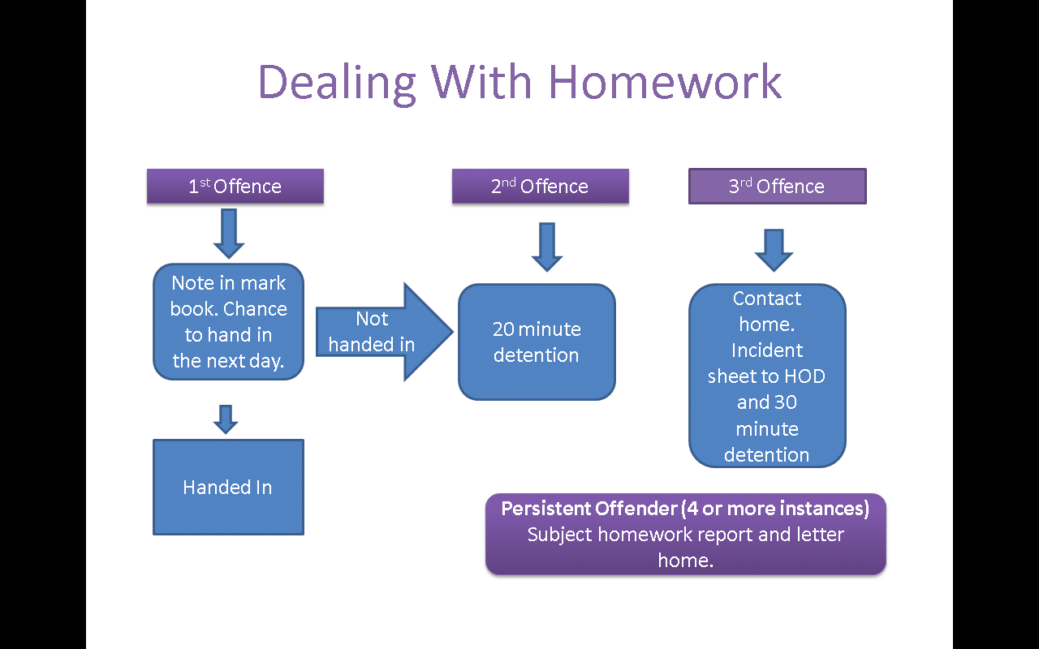

Guide to terms referring to school staff:
YLC-Year Learning Co-ordinator. This is the person in charge of the Year group.
LG-The Leadership Group (Head, Deputies, Assistant Heads)
CL-Curriculum Leader

Safer Schools Partnership
This scheme was introduced by the Government. It involves the Local Education Authority and Police working together to create a ‘Safer School Environment’. Swakeleys School, like all secondary schools in the Borough of Hillingdon, has an allocated ‘Safer Schools Officer’ (SSO)
Primarily, their role is preventative. Their aim is to work in support of staff, governors, students, parents and volunteers to reduce the risk of individuals becoming victims of crime or indeed criminals. If the circumstances determine, they will also liaise with outside community agencies.
However, SSOs do not lose their powers of enforcement and will resort to criminal prosecution in serious or persistent minor offences.

Peer on Peer Abuse
Issues of peer on peer abuse will be dealt with in line with the safeguarding policy. Where abuse is reported the investigation should be investigated in consultation with the Designated Safeguarding Lead.
Positive Handling
In certain situations a member of staff may need to handle a student. Any member of staff who supervises students is permitted to use ‘reasonable force’ as a measure of last resort to prevent real risk of danger or injury. The definition of ‘staff’ goes beyond teachers. ‘Reasonable’ means the force used must be proportionate and the minimum necessary to deal with the situation. The school will train key members of staff in the team teach approach to handling. All efforts should first be made to de-escalate the situation using other means. Please see the positive handling policy.
Pastoral Support Plan
Where a student is identified as being in need of extra support they may be placed on a Pupil Support Plan and offered and Early Help Assessment to provide extra support.

Managed Moves for Behaviour
A managed move application may be considered by the school and parents if all parties are in agreement that this may be the best form of support for the student and after all other avenues have been exhausted.
Success Criteria
This policy will result in all students feeling that the school offers them a positive learning environment free from poor behaviour, where they can succeed and achieve. All students feel safe in the school environment.
Monitoring
We will know whether this policy has been successful through our monitoring and evaluation programme and logging of behaviour incidents. In addition, through the views collected from parents/carers and students through questionnaires.
Evaluation
This policy will be evaluated as part of the annual process of Self Evaluation by the Deputy Headteacher and the Pastoral Leaders forum.
Review
This policy will be reviewed by the Pastoral and Curriculum Committee of the governing body.
This policy will be reviewed annually.
The next review will be in May 2019.

